Distracted Driving Fact Sheet

- Key Numbers

- 60% of drivers use cell phones while driving. (Harris Poll 2011)
- Talking on a cell phone quadruples your risk of an accident, about the same as if you were driving drunk. That risk doubles again if you are texting. (Univ. Utah research by Dr. David Strayer)
- Distracted driving is the number one cause of workplace deaths in the U.S. (Occupational Safety and Health Administration)
- Each day in the U.S., more than nine people are killed and more than 1,153 people are injured in crashes that are reported to involve a distracted driver. (Centers for Disease Control)
- An estimated 1 in 4 car crashes involves cell phone use. (National Safety Council)
- In 2013, 3,154 people were killed in distracted driving crashes. (National Highway Administration)

- What Happens When You Drive While Distracted

- When talking on a cell phone, drivers can miss seeing up to half of what's around them -- traffic lights, stop signs, pedestrians. (National Safety Council)
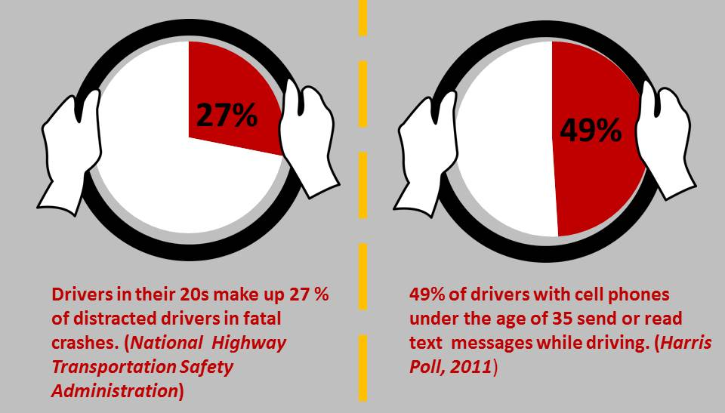
- Five seconds is the average time your eyes are off the road while texting. When traveling at 55mph, that's like driving across the length of a football field while blindfolded. (Virginia Tech Transportation Institute, 2009).
- Engaging tasks such as reaching for a phone, dialing and texting increased the risk of getting into a crash by three times. (Virginia Tech Transportation Institute, 2009)
- Phone conversations increase reaction times, variations in speed, lane deviations, and steering wheel control. (AAA Foundation)

- Most Impacted: Youth

- The youngest and most inexperienced drivers are most at risk – and pose the greatest risk to others. Drivers under 20 have the largest proportion of drivers who were distracted. (National Highway Transportation Safety Administration)
- Car crashes are the leading cause of death for American teenagers. Distraction is a factor in 58 percent of moderate to severe teenage auto accidents. Cell phone use is so consuming that half of all the teenagers who caused rear end collisions were still driving at full speed upon impact. (Automobile Association of America study, 2015)
- Drivers in their 20s make up 27% of distracted drivers in fatal crashes. (National Highway Transportation Safety Administration)
- 49% of drivers with cell phones under the age of 35 send or read text messages while driving. (Harris Poll, 2011)

