Rural Electric Safety Achievement Program
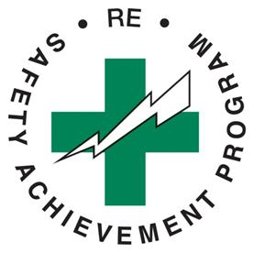

Guiding Principles

Safety is embraced as a core value
  - Actions and decisions reflect a fundamental and unwavering commitment to safety at all levels of the cooperative
  - Cooperative leadership accepts accountability for a culture that drives safety performance

Cooperative leaders and employees own the systems and processes that create a safe working environment
  - Safety systems, as a shared responsibility, focus on enhancing safe behaviors and reducing unsafe acts and risks to injury
  - Leaders commit to an environment in which all employees are owners of the safety culture

Administered by NRECA

