The Community Solar Playbook was created by the National Rural Electric Cooperative Association (NRECA) in collaboration with the Clean Energy Collective and support from the Meister Consultants Group and the National Consulting Group.

This document was prepared by Andrew Cotter of NRECA with contributions from the following:
- Mark Wilkerson and the entire team at Clean Energy Collective
- Henry Cano, Russ Wasson, Kaley Lockwood, and Tobeeb Lawal of NRECA
- Jon Crowe, Nathan Grady, Ryan Cook, Chad Laurent, and Wilson Rickerson of Meister Consultants Group

The Community Solar Playbook builds on the knowledge and experiences developed in the Department of Energy SunShot Initiative’s Solar Utility Network Deployment Accelerator (SUNDA). The SUNDA Team includes the following:
- Doug Danley, Paul Carroll, Deb Roepke, Mike Casper, Tracy Warren, TJ Kirk, and Kaley Lockwood of NRECA
- Krishna Murthy of the National Rural Utilities Cooperative Finance Corporation
- David True and Jocelyn Jordan of PowerSecure Inc., a Southern Company
- Staff from the entities listed below:
  - Anza Electric Cooperative
  - Brunswick Electric Membership Corporation
  - CoServ Electric
  - Eau Claire Energy Cooperative
  - Great River Energy
  - Green Power Electric Membership Cooperative
  - North Arkansas Electric Cooperative
  - Oneida-Madison Electric Cooperative
  - Owen Electric Cooperative
  - Pedernales Electric Cooperative
  - Sandhills Utility Services
  - Sussex Rural Electric Cooperative
  - Tri-State Generation and Transmission Association
  - Vermont Electric Cooperative

For more information about the Community Solar Utility Playbook, please contact:
Andrew Cotter, NRECA Mark Wilkerson, Clean Energy Collective Andrew.cotter@nreca.coop Mark.Wilkerson@easycleanenergy.com

Legal Notice
This work contains findings that are general in nature. Readers are reminded to perform due diligence in applying these findings to their specific needs, as it is not possible for NRECA or its contributors to have sufficient understanding of any specific situation to ensure applicability of the findings in all cases. The information in this work is not a recommendation, model, or standard for all electric cooperatives. Electric cooperatives are: (1) independent entities; (2) governed by independent boards of directors; and (3) affected by different member, financial, legal, political, policy, operational, and other considerations. For these reasons, electric cooperatives make independent decisions and investments based upon their individual needs, desires, and constraints. Neither the authors nor NRECA assume liability for how readers may use, interpret, or apply the information, analysis, templates, and guidance herein or with respect to the use of, or damages resulting from the use of, any information, apparatus, method, or process contained herein. In addition, the authors and NRECA make no warranty or representation that the use of these contents does not infringe on privately held rights. References to specific vendors shall not be construed as endorsements of any kind. This work product constitutes the intellectual property of NRECA and its licensors, and as such, it must be used in accordance with the NRECA copyright policy, unless specifically stated otherwise in this document. Copyright © 2016 by the National Rural Electric Cooperative Association.
Foreword: The Community Solar Playbook
America’s Electric Cooperatives have been at the forefront of community solar photovoltaic (PV) development. In keeping with the spirit of the network, a number of cooperatives and NRECA are working together and with other partners to share their combined knowledge. NRECA’s Community Solar Playbook is a comprehensive guide that combines the experience of America’s electric cooperatives and the knowledge of the solar vendor community with the tools and resources developed at NRECA to help other cooperatives save time and resources in the design and development of community solar programs.
The Community Solar Playbook is the latest entry in a series of resources that your cooperative can use as templates as you go through the process of evaluating and potentially deploying a community solar project. The full set of resources provides objective information about PV technology through fact sheets, courses, and case studies. These resources also capture practical design, implementation, and operational practices for large-scale PV systems (the SUNDA Cooperative PV Field Manual and the Community Solar Playbook).
In the near future, there will be tools that provide templates for other consumer-centric programs for solar offerings and beyond. Look for the technical overviews, uses, and templates for offerings such as residential rooftop programs; C&I programs; and combined PV, energy efficiency, and battery system offerings.

For more information, contact Andrew Cotter at Andrew.Cotter@NRECA.coop.
Contents
Module 2: Marketing, Member-Consumer Services, and Communications 5
Marketing Checklist 7
Marketing and Member Service Planning for the Community Solar Program 8
Market Research and Demand Analysis 10
Communicating the Value Proposition 13
Developing a Marketing and Communications Plan and Timeline 15
Onboarding Participants 20
Advertising and Media 21
Implementing Member-Consumer Service and Ongoing Consumer Engagement 23
After the Launch: Pulse Marketing 26
Sample Marketing Materials 27
Resources for Marketing Managers and Communicators 33

Module 2: Marketing, Member-Consumer Services, and Communications

About this Guide
Cooperatives have been early leaders in community solar photovoltaic (PV) development. At the same time, community solar program designs remain dynamic and there are opportunities for early adopters to benefit from emerging innovations. To help other cooperatives save time and resources, this Playbook provides community solar decision tools that share experiences and facilitate peer learning. These tools include resources to support (a) community solar program design and (b) community solar program implementation.
This Marketing, Member-Consumer Services, and Communications Module is one of 5 modules developed by NRECA, collectively forming the Community Solar Playbook. Each module is focused on the actions required from a particular division of a cooperative utility to establish a CSP, including the following:
- Executive Management
- Board of Directors Guide
- Marketing, Member-Consumer Services, and Communications (this document)
- Information Technology to Support Marketing and Program Administration
- Business, Finance, and Program Administration
- Section 1: Project Management and Planning
Section 2: PV System Engineering, Commissioning, and Operations

How to use this guide
You are not in this alone! Co-ops across the country are installing community solar, and communicators are developing plans and materials. This guide gathers lessons learned from both co-ops and private industry. This guide assumes the following: The co-op board has decided to do solar. The Community Solar Playbook focuses on the “how” rather than the “why.” If your co-op is still evaluating PV options, see the webinar Does Solar Make Sense? or the Project Manager’s PV Quick Start Guide.
- Consumers are becoming increasingly aware of the availability of solar DER. The depth and details of this guide reflect a need to remain competitive in meeting member-consumers’ clean energy needs.
- Bigger is better. Although some co-ops have successfully implemented small demonstration projects to serve a limited number of member-consumers, larger projects take advantage of the economies of scale to enable lower-cost offerings and the direct engagement of more member-consumers. Thus, the Community Solar Playbook assumes a project of at least 250 kW.

Some parts of this document will be more relevant to you than others. We hope you will find this document and accompanying samples useful.

Introduction
This module has been developed for Marketing and Project Managers with responsibility for marketing the program to members and publicizing it.
This module includes the following:
- Marketing Checklist
- Marketing and Member-Consumer Service Planning for the Community Solar Program
- Market Research and Demand Analysis
- Developing a Communications Timeline
- Communicating the Value Proposition
- Sales Onboarding Document
- Advertising and Media
- Developing a Marketing and Communications Plan
- Implementing Consumer Service and Ongoing Consumer Engagement Plan
- Resources for Marketing, Member-Consumer Services, and Communications
  - Sample Marketing Materials
  - Tools and Resources from NRECA
  - Additional Online Training Courses

A note about the budget for marketing and communications: Don’t skimp on personnel or research.
- The program should have a team member dedicated to outreach. Experience shows that associated costs and overhead of a CSP are typically lower with a dedicated Marketing Manager than when the duties are distributed among staff and departments.
- An up-front investment in market research should yield a better payback in the long run.
- There is no one-strategy-fits-all plan; each market or region varies. Do your research on member interest and develop a comprehensive outreach plan that reaches potential participants through a variety of channels.

Marketing Checklist
The Marketing Manager is responsible for developing the Marketing and Communications Plan and ensuring its execution over the course of the program. For some co-ops, contracting with an outside firm to handle marketing, including consumer-member service, may make sense. Co-ops with limited staff may find managing a dedicated call center, IT platforms, as well as sales and marketing, challenging.

The checklist below outlines the steps to creating and executing a comprehensive marketing and communications plan.

Table 1: Marketing Manager Checklist
MARKETING & MEMBER-CONSUMER SERVICES |  | CEO | LEG | BOD | MKT | IT | FIN | PM
 | Conduct market research and demand analysis
 | Develop communications planning timeline
 | Develop the Value Proposition Document
 | Create the Sales Onboarding Document, including establishing the application process and enrollment options
 | Assess the value of online consumer management tools
Develop a detailed Marketing and Communications Plan for CEO approval that includes:
- Member-consumer value proposition
- Market analysis
- Communications strategy
- Advertising plan/timeline
- Personnel time/material requirements
- Consumer service and sales training program
- Consumer “self-serve” automation and data collection service
- Marketing budget
 | Develop marketing collateral – ads, online tools, pitch book
 | Ensure that marketing materials are reviewed by legal counsel
 | Oversee staff training, including consumer service call center
 | Execute marketing campaign
 | Monitor and evaluate effectiveness

Marketing and Member Service Planning for the Community Solar Program
Market research and outreach planning can make or break a community solar initiative. Developing consistent and comprehensive plans for advertising, budgeting, staffing, and IT communications – and properly implementing those plans after the project launch – is critical to ensuring success and maintaining a strong and committed stakeholder base. Furthermore, conducting targeted market research and assessing the nature of the demand will not only help in setting achievable targets, it will also guide the development of your communications and advertising strategies.
TIP: Time Commitment
It must be noted that it can take several hours of one-on-one member engagement to adequately communicate the Value Proposition in a way that produces a sale. This can be reduced significantly via website engagement.

Business Case Contribution and Planning Overview
The primary planning role of the Marketing and Consumer Services Manager is to develop the Value Proposition Document, assess the market for community solar, and develop a communications plan and a marketing strategy.
Note on Cost Savings and Environmental Benefit Claims:
Cost Savings: The FTC Green Guidelines require that marketers qualify these types of claims to prevent deception about the nature of the environmental benefit being asserted.

Environmental Benefits: It can be claimed that community solar allows consumers to participate in the production of renewable energy, and it may or may not involve the consumption of renewable energy. Any cooperative pursuing community solar should retain and use legal counsel. In addition to legal counsel, cooperatives may work with a community solar vendor that has REC knowledge to develop marketing guidelines and/or review claims about renewable attributes.
All environmental and cost saving representations must be reviewed and approved by legal counsel.

Working in conjunction with the CEO, the Marketing Manager will craft the Value Proposition Document. The value proposition needs to be clearly understood by everyone who will interface with member-consumers. It is the basis for establishing clear internal guidelines for all communications regarding the solar initiative.

The main points of the Value Proposition Document should include the following:
- There will be no solar panels on your roof
- You may save money on your electric bill (assuming this is appropriate under FTC Green Guidelines)
- It is good for the environment
- It is easy; there is no maintenance
- It is local

Additionally, the Marketing Manager will contribute market data and analysis to support staff in developing risk assessment and mitigation strategies. These include the following:

Possible Risk Area | Mitigation
Risk of doing nothing | - Comprehensive scan of the competitive environment trends, economics, and other drivers for community solar
Lack of participation or underperforming subscriptions and the impact on revenue recovery | - Clearly describe the overall value proposition  - Ensure a comprehensive marketing and communications plan
Staffing risk | - Ensure that the assigned Project Manager and other key staff have the right skills, capabilities, and bandwidth  - Cost-benefit analysis of insourcing vs. outsourcing various duties  - Management commitment to provide adequate resources to the project

The most critical role of the Marketing Manager in the planning process will be to develop a Marketing and Communications Plan for inclusion in the business case. It will include the following:
- Summary of market analysis
- Member value proposition
- Name or brand of the offering
- Communications strategy
  - Messaging approach consistent with the overall value proposition statement
  - Assessment of the target member-consumer segment
  - Assessment of consumer management tools, “self-serve” automation, and data collection service
  - Establishment of a consumer service and sales training program
  - Ensure a culture in which the message is clear and accurate
- Advertising plan/timeline
- Onboarding Document
- Marketing budget
- Personnel time/material requirements

Additionally, as part of developing the Marketing and Communications Plan, the Marketing Manager will support staff by doing the following:
- Developing (with IT) an Onboarding Document outlining the application and enrollment process
- Assessing the value of online consumer management tools and recommending options
- Ensuring that marketing materials are reviewed by legal counsel; documenting the guidelines

Market Research and Demand Analysis
In-depth market research and demand analysis are key ingredients to a successful program. Since no two markets are the same, and consumer preferences and motivations can vary widely from region to region, quality up-front research can save significant amounts of money and effort during the marketing, education, and member-consumer engagement phases of the project.

The Marketing Manager will be responsible for conducting market research, which may be a member-consumer survey, focus groups, or both, and evaluating the demand for solar. Detailed research will assist the co-op’s advertising efforts.

Existing research may already provide this information, or the co-op may have to conduct its own surveys or focus groups. The research should also uncover what co-op members are hearing from others, including solar vendors. Note that a small number of rooftop systems on consumers’ homes does not necessarily represent low member-consumer interest.

A successful CSP must not only meet service needs and fulfill stakeholder promises, but also strengthen the bond between the member-consumer and the co-op while enhancing member satisfaction.

Prospective questions to answer include the following:
- What does the existing research say about technology choice and consumer trends?
TIP: Solar 4R Schools
The Bonneville Environmental Foundation provides assistance, including some grant monies, for implementing community solar projects in partnership with schools and other stakeholders. Information available at: http://www.b-e-f.org/environmental-projects-and-programs/solar-4r-schools/

- What are the levels of awareness of solar programs within the co-op’s service territory?
- Who is likely to participate?
- What might motivate them to participate?
- How much are they willing to pay?
- Would member-consumers prefer paying up front or paying as they go?
- How important is a no-down-payment option, and would a lease program be satisfactory?
- What are the consumer-members’ expectations for a solar program?
- What is the competition doing (offerings, cost, sales pitch)?
- What, if any, negative perceptions regarding the cooperative need to be addressed?
- How does the co-op’s offering stack up with the competition’s offering(s)?
- How could the co-op leverage a CSP to foster economic development, make connections between member-consumers or within the community, and/or serve consumers with low or moderate incomes?

These data will be used to identify the segments of the co-op’s membership most likely to sign up for the program. In addition, the market data will be useful in assessing and mitigating risks. Possible risks include the following:

Possible Risk Area | Mitigation
Risk of not providing members with a solar option | - Comprehensive scan of the competitive environment, member views and opinions, economics, and other drivers for community solar
Lack of participation or underperforming subscriptions and the impact on revenue recovery | - Clearly describe the overall value proposition  - Ensure a comprehensive marketing and communications plan
Lack of resources | - Ensure that Project Manager and other key staff have the right skills, capabilities, and bandwidth  - Cost-benefit analysis of insourcing vs. outsourcing various duties  - Management commitment to provide adequate resources to the project
Most energy cooperatives opt for one of two primary methods for conducting this research – surveys or focus groups. For a summary of pros and cons of each method, see Table 2, below.

In either case, at a minimum, your research should determine the following:
Tip: Market Research
Before conducting market research, develop a reliable process for capturing contact information from participating member-consumers.

- What is the level of interest in solar energy and community solar among your co-op’s member-consumers?
- What are your member-consumers’ primary concerns and/or motivators when considering solar (e.g., savings, lack of maintenance, environment)? If the primary motivator is savings on their electricity bill (as is common), how do they prefer to reap those savings?
- Would member-consumers prefer paying up front or paying as they go?
- How important is a no-down-payment option; would they be satisfied with a lease program?
- What is the level of trust in the co-op as a source of information and purveyor of energy options?
- What is the level of interest among your key accounts and other large consumers?

Table 2: Surveys or Focus Groups?
Method | Pros: | Cons: | Options
Surveys | - Can be effective with as few as 300‒500 participants  - Low cost: $1,000‒$1,500  - Requires less staff time  - Can get feedback quickly  - Easy to benchmark results | - Assumes you have the staff to conduct the survey effectively  - Effort is wasted and can alienate respondents if it is done improperly  - Limits feedback responses to available options  - Cumbersome to make follow-up inquiries | - NRECA or third-party firm could conduct survey and analyze the results if co-op lacks internal experience
Focus Groups | - Can be effective with as few as 8‒10 people per group, and 4‒6 groups per market  - Provides the opportunity to dynamically adjust the conversation to explore concepts in further depth as conversation dictates  - Enables flexibility within discussion | - More expensive, and requires more staff time if conducted internally  - Might be hard to recruit diverse participants  - Requires greater commitment by senior personnel to be engaged in the process | - NRECA or third-party group could conduct focus groups if time requirements are too great

Communicating the Value Proposition
Everyone involved in the project and every co-op employee needs a clear understanding of the value proposition, which is the most important element in developing a strategic outreach plan. It is contained in a one-page document that lays out how members will benefit from participation. Experience shows that consumers find the following benefits persuasive. Note that several of these benefits point out the advantages of community solar over residential solar. Also note that any cooperative pursuing community solar should retain and use legal counsel to review any environmental and cost saving representations. In addition to legal counsel, cooperatives may work with a community solar vendor that has REC knowledge to develop marketing guidelines and/or review claims about renewable attributes.

Points of Emphasis:

- You may save money on your electric bill
If the member-consumer is expected to pay a premium for solar, or there is no financial benefit, the co-op may want to reconsider the project. Most successful programs to date have made electricity cost savings an essential feature of their CSPs. The majority of member-consumers expect to save money – at least in the long term. It is important to note that FTC Green Guidelines require that marketers qualify these types of claims to prevent deception about the nature of the environmental benefit being asserted.

- No solar panels on your roof
This point must be emphasized because even if people hear it and see the large-scale array at a distant location, it is a common misconception of residential users that solar means “on their roof.” In fact, research and experience shows that concern surrounding equipment penetrating the roof is actually a primary reason that pro-solar member-consumers resist rooftop installation. Thus, it is important to emphasize this distinction consistently and early on.

Additionally, steering away from rooftop solar and broadly communicating this fact could bring in additional member-consumers, since it opens the market to renters, high-density/multifamily housing, heavily shaded areas, etc.

- Good for the environment

Although many people are motivated by doing something good for the environment, when it comes to signing a contract and paying for solar, it is rarely the deciding factor. Despite this fact, once people have made the decision to switch to solar energy, they do want to enjoy the social benefits of that association. Because a share in a CSP is less visible than rooftop solar, it can be beneficial to promote a method for member-consumers to advertise that choice, such as window decals or yard signs stating, “This house/business/organization is powered by the sun.”
- No maintenance
The fear of an unknown amount of maintenance stemming from owning a solar system can be a significant deterrent to installing rooftop solar. Community solar alleviates this concern, as it puts the responsibility of ongoing operations and maintenance on the co-op.

- Local
Your local cooperative takes on the risks and hassles so member-consumers can invest in and benefit from solar development. With community solar, the benefits all stay in the community.

The information listed above is derived from years of experience and direct feedback on what has worked for other cooperatives. Similarly, the following list has hindered the execution and success of a CSP.

Things to Avoid:
- Being overly optimistic regarding consumer interest
It is important to create realistic expectations, both internally and with the public. Unrealistic expectations can lead to embarrassment for the co-op, or worse.

- Cost discussion
Any discussion of cost and savings must be within the context of the real effect on the member-consumer’s monthly electric bill. Savings, even minor ones, will generate a positive effect on the program. Unrealized promises of savings will generate a negative effect.
- Overemphasis on environmental benefits
Those consumers seeking environmental benefits as a priority will continue to do so regardless of a marketing effort. Other members will still feel good about helping the environment even if their decision was based on savings.

- Using the term “utility-scale solar” with member-consumers
Based on focus groups conducted with cooperative consumers in multiple states, consumers often interpret this language as associated with big government or a government subsidy.

Developing a Marketing and Communications Plan and Timeline
The following should be completed prior to developing the Marketing and Communications Plan:
- An Onboarding Document, coordinated with the IT staff, outlining the application and enrollment process
- A review and assessment of online consumer management tools
- Legal counsel review of the Value Proposition Document and the onboarding process

Marketing and Communications Plan:
The Marketing Manager will develop a Marketing and Communications Plan for inclusion in the business case. It will include the following:
- Summary of market analysis
- Member value proposition
- Name or brand of the offering
- Communications strategy
  - Messaging approach consistent with the overall value proposition statement
  - Assessment of the target member-consumer segment
  - Assessment of consumer management tools, “self-serve” automation, and data collection service
  - Establishment of a consumer service and sales training program
  - Ensure a culture in which the message is clear and accurate
- Advertising plan/timeline
- Onboarding Document
- Marketing budget
- Personnel time/material requirements

Developing a Marketing and Communications Plan
The Marketing and Communications Plan is a central component to the overall business plan for the CSP. The Marketing Manager will need to address, at a minimum, the following issues within the document.

- Member value proposition ‒ Describe the potential strategic advantages and related business drivers when considering a CSP. The consideration should have a clear rationale, aligned with the cooperative’s strategic direction and mission.

- Market analyses (see above) ‒ Review the market research and demand analysis. Prioritize market segments: which groups of members are most likely to participate? How can you reach them? What messages and which media will work best?

- Communications strategy ‒ Considering the program goals, outline various approaches to market and communicate the solar program. Possible areas include the following:
  - Formulate messaging consistent with the overall value proposition statement
  - Decide how to name or brand the offering
  - Assess the target member-consumer segment
  - Distill a clear communication brief on how member-consumers can participate
  - Outline various communication channels
- Publicity, advertising, marketing, and education – The communications plan could include all or a combination of the following:
- Publicity: public events, news releases, free (“earned”) media opportunities, general outreach
- Advertising and marketing: paid media such as television, radio, newspaper, and social media to make members aware of the opportunity
- Education: co-op newsletters and bill stuffers, and other outreach channels

- Personnel time/material requirements ‒ Evaluate comparable costs and production differences between using co-op staff to execute the functions vs. using a third party.

- Consumer service training needs ‒ Of note, different community solar business models may require very precise descriptions and wording. Legal counsel should review program messaging and work with marketing to develop “do’s and don’ts” for developing new material.

- Consumer “self-serve” automation and data collection service ‒ The plan development process should include an assessment of the value of automated online tools. This should be done in conjunction with the IT planning.

A communications timeline will help your marketing staff stay on task and ensure timely production and dissemination of materials to employees, Board members, member-consumers, and external stakeholders.

- Board members and employees
Draft a plan for engaging Board members and employees in your initial outreach efforts. This plan should include deadlines for producing materials that will aid in starting conversations with member-consumers and provide them with information they want and need about the program.

- Member-consumers
An effective member-consumer outreach plan will seek to utilize a variety of dissemination channels to reach likely participants at least three times with information about the program. For example, one member-consumer might receive a bill insert, hear a radio advertisement, and/or see a Facebook post. Another might see a notice on the co-op website, talk to a co-op employee, and/or read about the program in the co-op newsletter. Regardless of the channel, the point is to diversify outreach efforts to maximize the ways in which consumers can be reached. Again, the plan should include deadlines and milestones for newsletter articles, bill inserts, FAQs, schedules of member-consumer meetings, radio ads, direct mail, and key account visits.

- External stakeholders (media, public officials, civic organizations)
An effective plan to promote the community solar concept to external stakeholders will start out by answering the question: What attributes distinguish this project from other solar projects, including rooftop solar? The answer to this question should be communicated to stakeholders, first by letter and later in person.

Additionally the Marketing Manager should obtain a schedule of local community events, especially fairs and expos, and make sure the co-op’s solar project is visible. Plan to have someone from the co-op attend civic and public meetings to discuss the project.

Sample Communications Timeline
Internal project launch
- Initiate Board engagement:
  - Board presentation
  - Preliminary marketing materials, such as brochures, pocket cards, etc.
  - Legal review of communications and marketing proposals
  - Initial market research and demand analysis

- Initiate employee engagement:
  - Finalize marketing materials, such as brochures, pocket cards, etc.
  - Employee presentation
  - Consumer service relations and member-consumer services training for fielding consumer’s inquiries and marketing the program

- Schedule project updates:
  - Determine ribbon-cutting dates and adjust timeline accordingly
  - Coordinate with and periodically update staff and Board

Initiate member-consumer marketing:
TIP: Generating Promotional Materials
Don’t reinvent the wheel. A lot of quality promotional materials are out there and, with written permission from the source, could be adapted or tailored to your community solar initiative. Particularly with member-based G&Ts that have attempted community solar, collaboration can be a real asset and save considerable time and expense, so don’t be afraid to reach out to similar cooperative networks.

- Project announcement (6‒9 months before ribbon cutting)
First wave of communication to member-consumers announcing the project:
  - Create community solar webpage
  - Disseminate FAQs
  - Introduce project branding

- Targeted outreach (3‒6 months before)
Robust dissemination of information via newsletters, social channels, and – most important – in-person outreach at meetings and events:
  - Dissemination through co-op channels, including social media
  - Dissemination through community meetings and events
  - Paid advertising
  - Sponsorship advertising (sponsor the local weather – on sunny days)
  - Follow-up market research to assess changes in demand from advertising

- Publicity around system completion:
  - Press release announcing the project; should include information about why the co-op is pursuing community solar and how member-consumers can participate
  - Press release announcing the site selection

Ribbon-cutting event
- Begin planning about 3 months before:
  - Invite local officials, community leaders, and key stakeholders at least one month before
  - After confirming attendees, invite local media 1‒2 weeks before
    - Press release when the project breaks ground
    - Press release announcing when the array first produces power
    - Public service announcements

Pulse marketing
- Create opportunities to continue the marketing push after the project goes online:
  - Special offers
  - Educational programs and tours
  - Milestone announcements
  - Digital ads on local radio and TV websites – cheaper and effective

Onboarding Participants
The “onboarding” process is essentially the entire consumer engagement life cycle, from the moment the co-op presents an offer to the moment of receiving payment. Consumer satisfaction depends on this process being smooth and hassle-free. The Marketing Manager should work with the IT Manager, Business and Finance Manager, and member-consumer services and other staff to create a Sales Onboarding Document that lays out the process so that when a potential member-consumer expresses interest either in person, on-line, or over the phone, the member engagement team can quickly close the deal. Automation can play a key role in this process.

The Onboarding Document will be the basis for comparing the speed and value of automation versus manual processing.

The Onboarding Document should capture the following:
How the member-consumers can communicate their interest to the co-op
The documentation required for subscribing
Where the documents reside
How member-consumers are charged/how the subscription information is integrated into billing
How member-consumers receive information regarding their pro-rated share of community solar benefits
How member-consumers can ask questions and change subscriptions
What is considered personally identifiable information (PII), payment information, or consumer usage data that would be sensitive if released to the public, and how confidentiality for that subset of information will be managed

Advertising and Media
The overall integrated Marketing and Communications Plan should include an advertising strategy, which should focus on leveraging trackable media (such as social media platforms, where user responses can be tracked). Investment in a tracking system is recommended to estimate website visits driven by print media, online display ads, and social media posts. Such a metric breakdown can be invaluable in developing your advertising approach.

Topics to Consider when Formulating an Advertising Strategy:
- Educate and encourage discussion
With a consistent approach to educating your member-consumers, you can create a “rising tide” effect – early success can bring in more member-consumers, which then can develop into an ongoing growth effect.

- Content marketing
Print and online media generally welcome local stories with positive appeal. This can provide free or low-cost exposure and may reach member-consumers outside of your current networks. To best achieve diverse dissemination in print media, many co-ops develop a mix of materials in addition to seeking articles in local papers. These include brochures, bill inserts, newsletter articles, FAQ sheets, logos, slogans, advertising copy, and graphics. Materials for your CSP should refer to materials from recent successful co-op ventures. See Sample Marketing Materials in the Resources section of this module for examples. Make sure that if using this approach, content marketing includes all required FTC disclaimers.

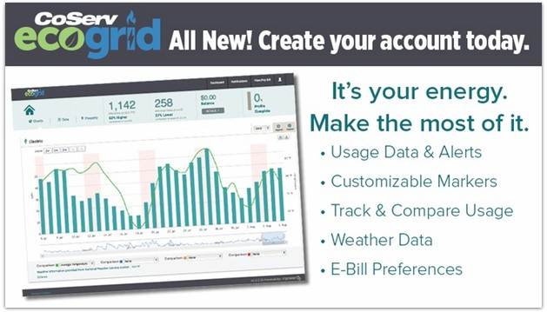
- Interactive online tools
Online tools encourage consumer self-service, shorten the consumer engagement cycle, and, if properly executed, can help create excitement around the program. Keep in mind that third-party partners may offer significant savings in time and resources by offering to customize existing online tools for your purposes. CoServ Electric’s online account, as seen in Figure 1, is a good example of a useful online engagement tool.
Figure 1: CoServ allows members to monitor their energy usage, set threshold alerts, and receive electronic bill notifications via text, voice, or email

- Face-to-face events
Participating in local, inexpensive events such as farmer’s markets, craft shows, etc. is a great way to educate the public about the concept of community off-roof solar. Pedernales Electric Cooperative’s Hill Country Solar Tour, outlined below, provides a good example of such a face-to-face education event.
Pedernales Electric Cooperative’s Hill Country Solar Tour:
For PEC, an annual community event, called the Hill Country Solar Tour, has been an effective way to share solar information with member-consumers; its popularity has been growing over the years, with nearly 400 in attendance in 2015. During the event, PEC has the opportunity to educate member-consumers about renewables as well as other company programs and initiatives, and members-consumers have the chance to talk with vendors and other consumers about their solar applications (rooftop), and learn about related savings and costs. Other communications efforts by PEC include attending local meetings and events of developers, Rotary Clubs, and Chambers of Commerce. For more information about this event, go to: http://pec.coop/Home/Energy_Services/altenergy/solartour.aspx.

Implementing Member-Consumer Service and Ongoing Consumer Engagement
To make the CSP successful, it is important that the member-consumer feels like he or she is dealing with knowledgeable, competent staff. From the very first phone call or visit to the website, it is important that member-consumer service representatives have ready access to specific consumer data to help people understand the impact their solar choices have on their electric bills. Ideally, a member-consumer could visit the cooperative’s website at any time, plug in his/her address, and easily see what different solar options are available and the impact on his/her bill.
There are available portals designed for just this purpose; to save on labor and development time, co-ops may make the strategic decision to outsource the portal responsibility. Generally, these portals can appear directly as part of a CSP’s website or can be hosted externally.
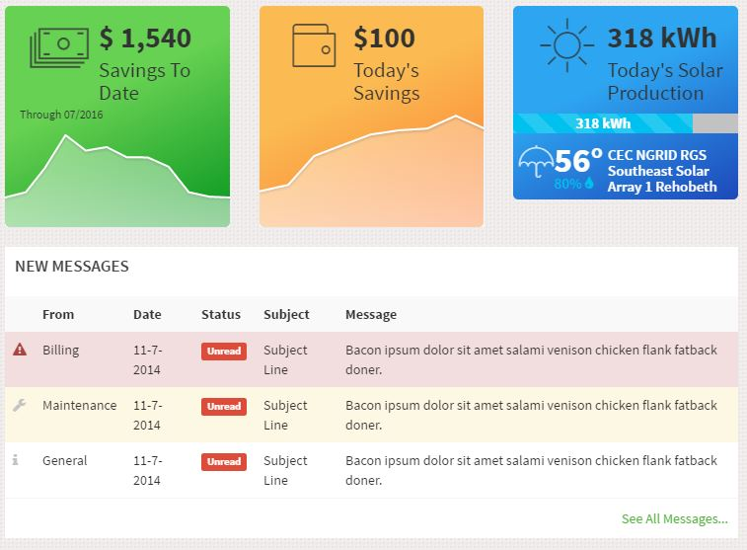
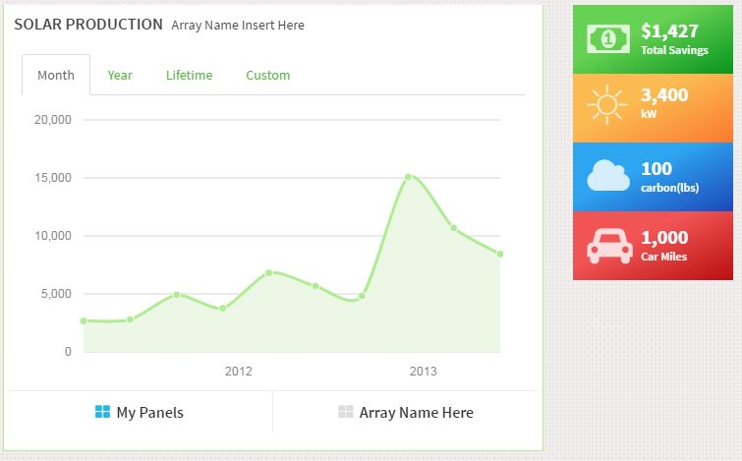
Figure 2: Member-Consumer Data Graphics Sample
Available at: http://www.morecleanenergy.com/graphics/v3-testing/moce-testing/moce/moce.html

Managing the member experience
System Performance and Individual Savings Data
Having the data readily accessible to member-consumers will enable the cooperative to stay ahead of issues and answer many of their questions directly, without co-op involvement. This includes bill impacts, questions about terms of the contract, or the process of signing up. People take comfort in being able to track their savings, compare week to week, and view their cooperatives’ overall energy production. Additionally, this information can serve as an easy first reference for member-consumer service representatives when questions or calls do come in and will likely resolve most consumer uncertainties.

Automation
Self-serve: As discussed above, easy member-consumer access can mitigate many basic concerns.
Newsletter: For general ongoing information updates, have a community solar section within the regular co-op newsletter.
Email: Establish automated communication of unusual events, both good and bad, such as ice storms that may reduce panel output, power outages that require the system to go offline, or particularly ideal weather that may lead to increased system performance. Make sure to provide reasons why the system performed as it did so member-consumers better understand their piece of the community solar system.

Implementing Member-Consumer Service Staff Training
The success of the program, as well as the reputation of the co-op, can live or die by co-op staff training and execution. If the co-op staff were to make untrue claims, even unintentionally, the co-op could be subject to regulatory or legal action and litigation. Also, the co-op does not want to invest time and effort in developing a CSP that does not satisfy its member-consumers. In addition to the risk of a poor reputation that can stem from a poorly received (undersubscribed) project, a direct cost is incurred in having underutilized equipment.

A stake in a CSP is essentially selling a ~20-year engagement with the consumer. Member-consumer engagement and satisfaction are critical to the success of the project. Time and effort put into training for staff at all levels will be well spent.

Figure 3: How to Ensure Quality Member-Consumer Service

After the Launch: Pulse Marketing
Many co-ops report that once the project comes online and the initial wave of members has signed up, sales lag. Pulse marketing refers to a steady stream of marketing activities that will keep the program fresh in the minds of co-op members. Research demonstrates that co-ops can fully subscribe their programs using this approach.
- Marketing tactics to consider following the launch
- Second wave of outreach to the segment most likely to participate
- Special offers to C&I members
- Special offers to non-profit members and their supporters
- Educational events such as tours for schools
- Social media promotions

Sample Marketing Materials
The following materials are provided as samples only. Each cooperative is expected to make its own independent business decisions.
Tri-County Electric Brochure:
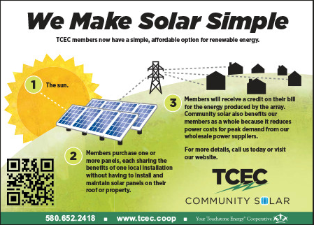

Tri-County Electric Press Release:
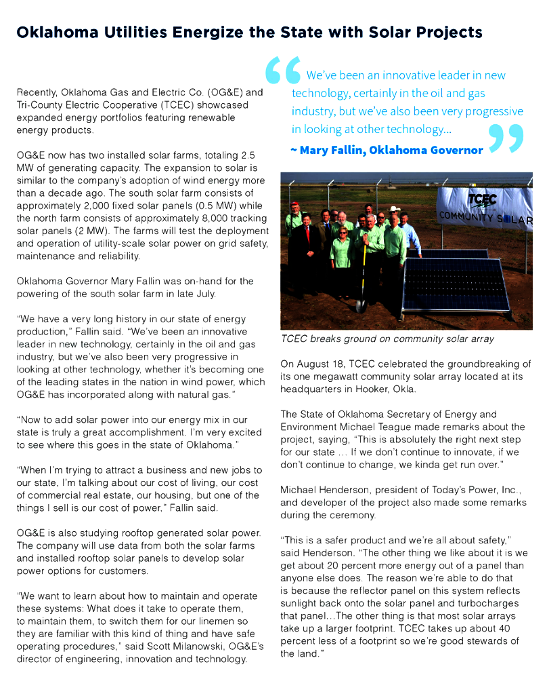

Platte-Clay Electric Cooperative Community Solar Brochure:
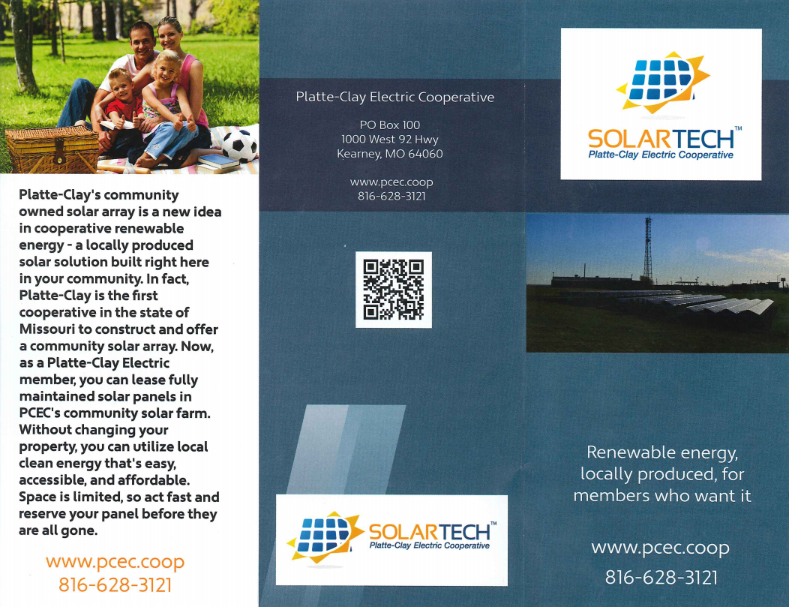
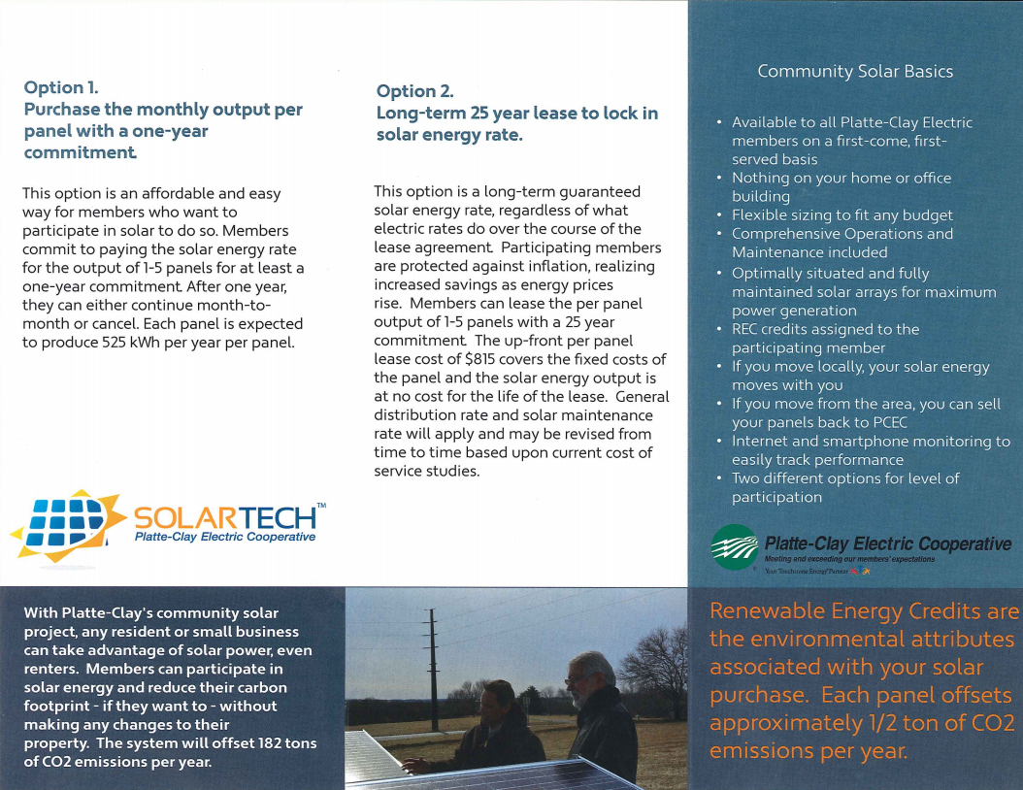

Eau Claire Energy Cooperative Brochure:

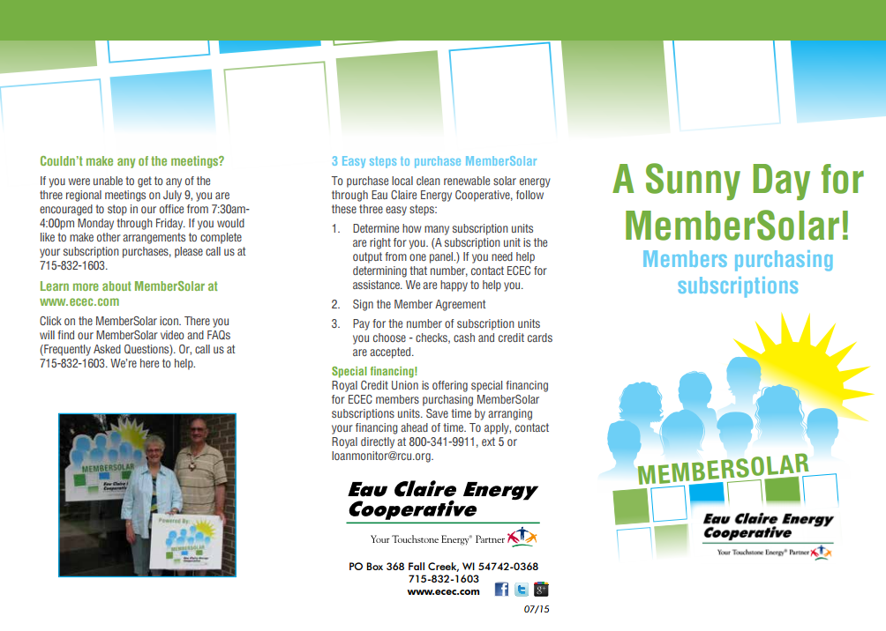
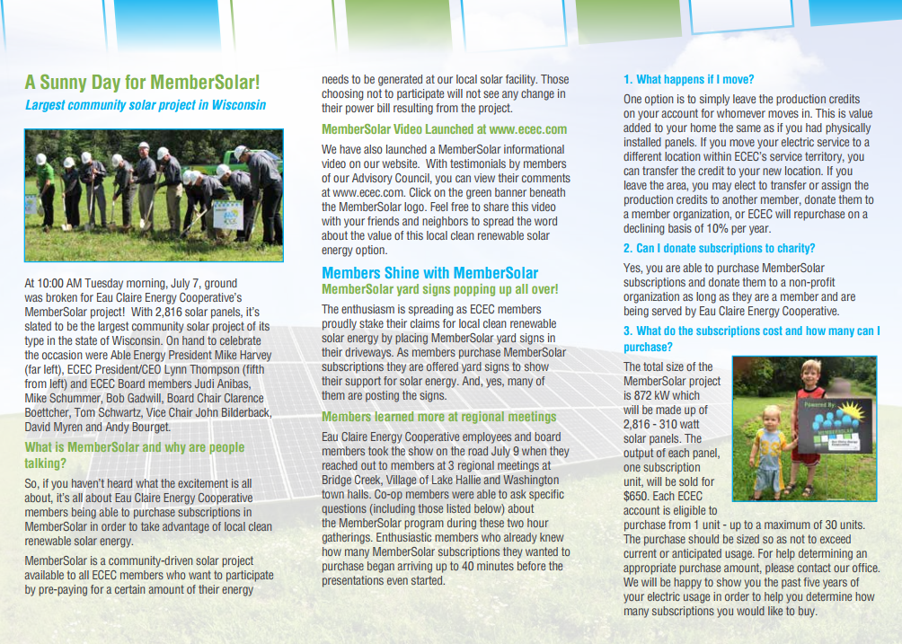

CoServ Electric Brochure:
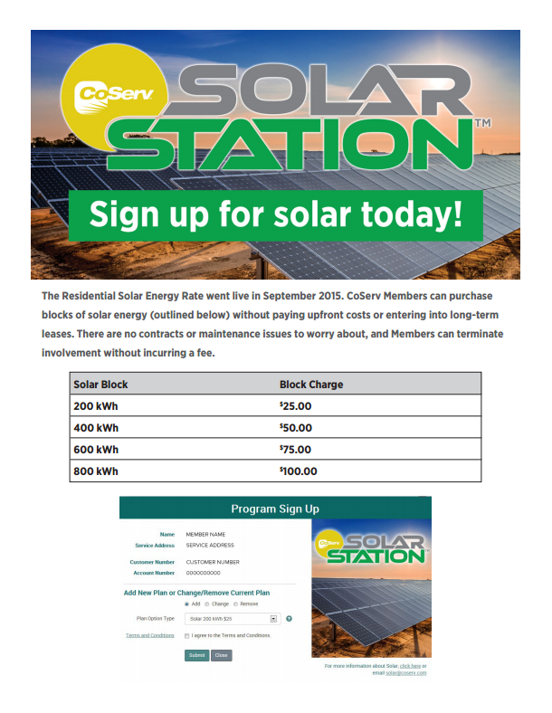

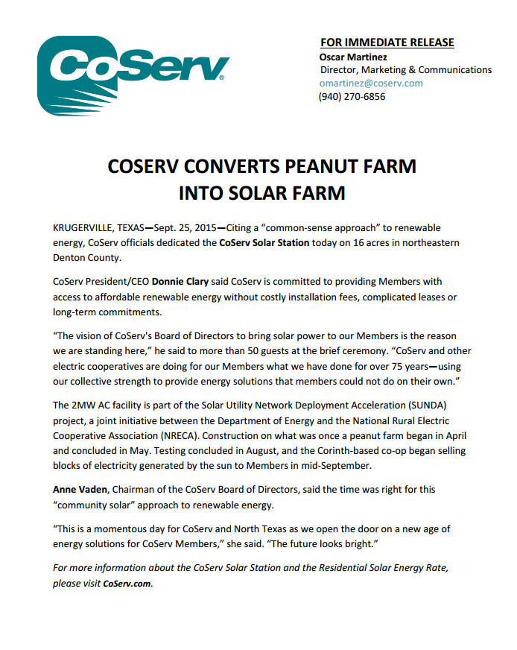
CoServ Electric Press Release:

Resources for Marketing Managers and Communicators

Tools and Resources from NRECA
National Consulting Group Policy Development Services for Community-Based Solar Projects
As interest in solar energy grows and the cost of deploying photovoltaic arrays becomes less prohibitive, many electric cooperatives are evaluating the feasibility of establishing CSPs. To assist with that process, NRECA is offering a suite of consulting services designed to help its co-op members deploy and operate solar generation projects.
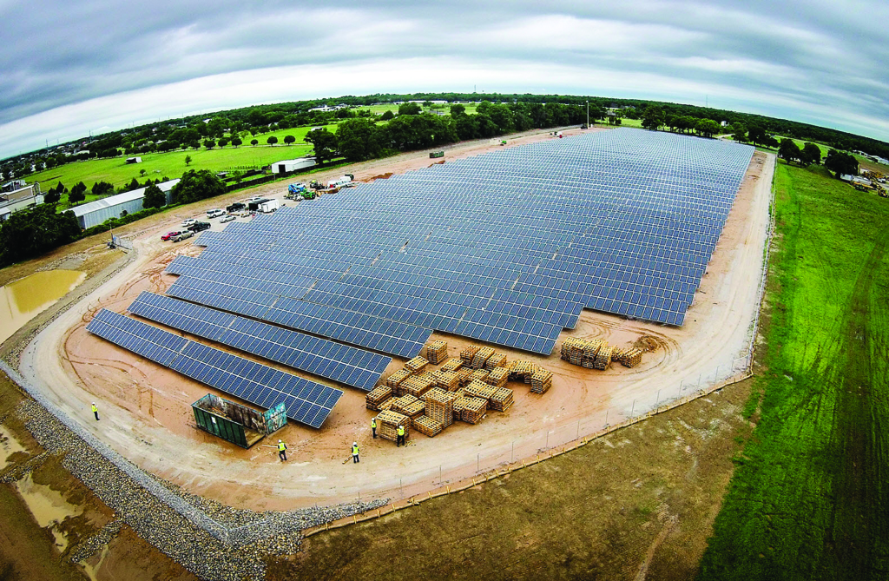
Through its National Consulting Group (NCG), and in collaboration with the association’s Business and Technology Strategies (BTS), NRECA is providing a resource to help mitigate cooperatives’ risks and costs – and increase the value of successful CSPs. NRECA’s consultants work alongside cooperatives’ personnel to evaluate and plan for the strategic, business, financial, and resource requirements of solar projects.

Our strategic consultants bring third-party value to the planning and development process, including assessment and creation of the strategic rationale for community solar. This process ensures that member co-ops and their consumers clearly understand the advantages and business drivers of proposed projects. Every co-op is unique, so we strive to provide a range of options that provide the best solution to each.

The overall principle for performing these services is one of guided facilitation:
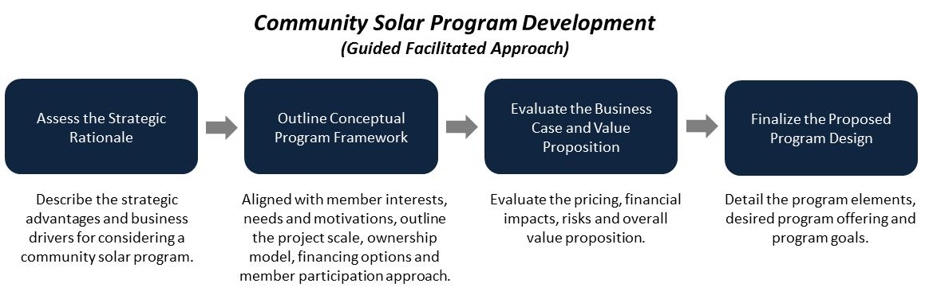
Contact: Henry.Cano@nreca.coop, 602-621-3905.

Solar Utility Network Deployment Acceleration (SUNDA)
NRECA created certain tools and resources pursuant to a DOE-funded project, the Solar Utility Network Deployment Acceleration (SUNDA). The purpose of the project was to enhance the ability of co-ops to design, deploy, and operate utility-scale, utility-owned solar PV systems at their facilities. Co-op project utilities installed more than 20 MW of utility-scale, utility-owned solar. SUNDA publications include the following:
1. Cooperative Utility PV Field Manual ‒ NRECA’s Cooperative Utility PV Field Manual is a three-volume series designed to support electric cooperatives as they explore utility-scale solar PV:
  - Volume I: Business Models and Financing Options
  - Volume II: Planning, Design, Installation/Interconnection, and Commissioning
  - Volume III: Operations, Maintenance, and Monitoring
- SUNDA Reference Designs – Templates to design for 250-kW (single inverter and string inverter design), 500-kW, and 1-MW utility-scale PV solar projects
- Project Managers Quick Start Guide – Summary and checklist of Project Manager tasks and documentation requirements
- Cost and Financing Screening Tool for Utility-Scale Solar Projects – Open and editable spreadsheet for project financial examination
- Solar Communications Planning Guide – Guide to creating a communications plan for a solar project launch and marketing for increased participation
Available at: www.nreca.coop/SUNDA
This work, authored by the National Rural Electric Cooperative Association, was funded in whole or in part by the Department of Energy under U.S. Government contract DE-EE-0006333.

Cooperative Solar Case Studies
The following eight case studies illustrate innovative ways cooperatives are satisfying member-consumers’ demand for solar-derived electricity:
- Tri-County Electric Cooperative
- Southern Maryland Electric Cooperative
- San Miguel Power Association
- Okanogan County Electric Cooperative
- Green Power Electric Membership Cooperative
- Cherryland Electric Cooperative
- Kit Carson Electric Cooperative
- Great River Energy

Also available at: http://www.nreca.coop/solar-case-studies/

Comprehensive Web-Based Courses
NRECA offers this series of online webinars to help cooperatives address and evaluate community solar options. Topics include the following:
- Strategic Business Options
- Financing Options and Cost Estimates
- Technical Project Management
- Communications Best Practices
- Case Studies from Electric Co-ops
Available at: http://www.nreca.coop/what-we-do/bts/solar-utility-network-deployment-acceleration-project/comprehensive-course/

Distributed Generation (DG) Toolkit
NRECA created this DG toolkit to help electric co-ops address the legal, economic, and technical issues raised by consumer-owned generation. These materials provide models and guidance that each co-op can adapt to its unique needs after consultation with management, legal counsel, and system engineers. We suggest beginning with the “Business and Contract Guide for Interconnection,” which will guide you through the process and provide descriptions for each of the documents. With this toolkit, each co-op should be able to independently draft the rules, policies, tariffs, contract documents, and retail rates required to respond to member requests for interconnection.
Available at: http://www.nreca.coop/nreca-on-the-issues/energy-operations/distributed-generation/

Additional Online Training Courses

State of Renewable Impact Analysis Software
This live 75-minute web conference presented by NRECA's Cooperative Research Network (CRN) provides co-ops with the basic technical guidance they will need to stay informed and on the leading edge of DG.
Available at: https://www.cooperative.com/conferences-education/web-conferences/pages/state-of-renewable-impact-analysis-software.aspx

MultiSpeak Integrator Training
Learn the advantages of implementing the MultiSpeak® specification and how it works during this in-depth training session for co-op staff, consultants, and software integrators. The workshop covers Version 3.0, which has been implemented at utilities since 2005.
Available at: https://www.cooperative.com/conferences-education/courses/multispeak/Pages/default.aspx

Developing a Cyber Security and Risk Mitigation Plan
NRECA’s CRN made news when it made the Guide to Developing a Cyber Security and Risk Mitigation Plan available to the public. Written for electric cooperatives, the Guide can be used by any co-op to start immediately strengthening its security posture and charting a path of continuous improvement. This one-day, 8-hour workshop introduces the Guide and its related documents, and walks participants through the process of developing their own cyber security plans. The workshop covers risks posed by people, processes, and technology, and also looks at NERC CIP compliance. After taking this class, co-op staff will be ready to create their own cyber security plans.
Available at: https://www.cooperative.com/conferences-education/Lists/Courses/DispForm.aspx?ID=2&Title=(175.1)+Developing+a+Cyber+Security+and+Risk+Mitigation+Plan
This work, authored by the National Rural Electric Cooperative Association, was funded in whole or in part by the Department of Energy under U.S. Government contract DE-OE-OE0000222.

Enhancing IT Effectiveness: Managing and Planning the IT Function
This 2-day course covers the management techniques, current practices, tools, and resources crucial for effective IT planning, decision making, and leadership. The program also introduces a step-by-step approach to developing a strategic IT plan and guides participants in creating the foundation of an IT plan that can be taken back to their cooperatives.
Available at: https://www.cooperative.com/conferences-education/Lists/Courses/DispForm.aspx?ID=23&Title=(781.2)+Enhancing+IT+Effectiveness:+Managing+and+Planning+the+IT+Function

Solar Tools: Getting Co-ops Up to Speed on Their Solar Options
NRECA has pulled together tools and resources to answer questions and help you make informed decisions when exploring the installation of your own solar arrays or participating in cooperative solar development, such as community solar. This webinar updates our online toolkit, which incorporates the experience and input from experts and consultants across the country.
Available at: https://www.cooperative.com/conferences-education/web-conferences/Pages/Solar-Tools-Getting-Co-ops-Up-to-Speed-on-Their-Solar-Options.aspx

ENTITIES Providing Community Solar Services

Executive Management, Governance, and Regulatory

Vermont Energy Investment Corporation (VEIC)
For three decades, the Vermont Energy Investment Corporation (VEIC) has provided energy services guided by our commitment to environmental and social justice, innovation, and results. VEIC provides utilities with program implementation and consulting services in energy efficiency, renewable energy, and transportation efficiency. VEIC specializes in policy and regulatory leadership, energy planning, financing and program design and review, grounded in our real-world experience delivering the awarding-winning programs Efficiency Vermont, the DC Sustainable Energy Utility (DCSEU), and Efficiency Smart. VEIC has consulted in Vermont and the District of Columbia to develop community solar regulations and creative models that include low-to-moderate income resident participation and employee/employer ownership.

Contact: Joananne Bachmann, Business Development & Sales Manager
Email: jbachmann@veic.org
Phone: +1.802.540.7838

Clean Energy Collective (CEC)
CEC utilizes its extensive experience to offer everything from turnkey CSPs to a comprehensive menu of products, software, and services to make each individual aspect of community solar a seamless process. CIC focuses on handling indemnity on securities and tax issues (SEC and IRS) as well as properly handling the ITCs, RECs and green claims for our partners. CEC’s policy team is a leader in the industry, active in virtually every interested state in driving toward positive CSPs and educating regulators, legislators, and stakeholders about the benefits of supporting such programs in communities.

Contact: Mark W. Wilkerson, VP Strategic Partnerships
Email: mark.wilkerson@easycleanenergy.com
Phone: +1.815.549.6051

Meister Consultants Group (MCG)
Meister Consultants Group provides expert technical and program assistance to rural electric cooperatives on a variety of clean energy programs including community solar projects. MCG works with cooperative leadership to understand, prioritize, and select community solar program design options, with an emphasis on developing community solar projects that are effective, financially sound, and in line with a cooperative’s organizational goals and principles. MCG provides targeted financial analysis that projects the financial impacts of programs on cooperatives and their members and supports rural electric cooperatives with member engagement and stakeholder education. MCG has worked with leading rural electric cooperative nationwide on community solar issues, and is a member of the White House Community Solar Partnership.

Contact: Ryan Cook, Consultant
Email: ryan.cook@mc-group.com
Phone: +1.617.209.1990

Marketing, Member-Consumer Services, and Communications

Clean Energy Collective
CEC has more experience in lead generation, sales conversion, and ongoing consumer engagement than anyone in the industry. CEC can offer everything from market research and consulting to a complete marketing suite, using consumer targeting and tactics that have been tested and refined in markets across the U.S. with multiple co-op partners. CEC continues to engage co-op member-consumers via production and credit tracking for the life of a project, as well as providing a custom portal through which consumers can view these numbers themselves on a computer or mobile or tablet device. CEC manages operations and maintenance of the array for the life of a project so that co-ops do not need to worry about them.

Contact: Mark W. Wilkerson, VP Strategic Partnerships
Email: mark.wilkerson@easycleanenergy.com
Phone: +1.815.549.6051

Meister Consultants Group (MCG)
Meister Consultants Group provides expert technical and program assistance to rural electric cooperatives on a variety of clean energy programs including community solar projects. MCG works with cooperative leadership to understand, prioritize, and select community solar program design options, with an emphasis on developing community solar projects that are effective, financially sound, and in line with a cooperative’s organizational goals and principles. MCG provides targeted financial analysis that projects the financial impacts of programs on cooperatives and their members and supports rural electric cooperatives with member engagement and stakeholder education. MCG has worked with leading rural electric cooperative nationwide on community solar issues, and is a member of the White House Community Solar Partnership.

Contact: Ryan Cook, Consultant
Email: ryan.cook@mc-group.com
Phone: +1.617.209.1990

Information Technology

Clean Energy Collective
Through its proprietary software platform, as well as experience in working with numerous co-ops, CEC can ensure compliance with a wide range of billing systems. CEC provides automated reconciliation and application of solar panel production onto participating member-consumers’ accounts; an online credit check with adverse action letter (legal requirement); and e-commerce that allows for a quick, easy sign-up – all of which is entirely member-consumer driven and significantly eases the workload of a co-op’s employees in signing up member-consumers manually. CEC also provides multiple encryption options and secure consumer data-handling procedures.

Contact: Mark W. Wilkerson, VP Strategic Partnerships
Email: mark.wilkerson@easycleanenergy.com
Phone: +1.815.549.6051

Federated Rural Electric Insurance Exchange
Federated Rural Electric Insurance Exchange (Federated) is the leading provider of property and casualty insurance for rural electric cooperatives in 43 states. Federated is the only property/casualty insurer owned by the rural electric cooperatives. Its primary goal is to offer its co-ops the best insurance value while maintaining a stable, secure insurance market. Since Federated was formed, it has returned $322.6 million in cash and equity to its rural electric member co-ops.

Contact: Bill West
Email: wcw@federatedrural.com
Phone: +1.800.356.8360

National Information Solutions Cooperative (NISC)
National Information Solutions Cooperative (NISC) is a member-owned information technology cooperative that provides software and services to more than 750 community-based utility and telecommunication providers located in 49 states, Canada, American Samoa, and Palau.
Based on iVUE, its enterprise software solution, NISC offers accounting, consumer care solutions, and a suite of Smarter Grid solutions, which include meter data management systems (MDMS); prepaid metering; web-based and mobile consumer presentment, reporting, and payment tools; mobile workforce automation; mapping; outage management; and distribution analytics solutions. Additional information can be found at www.nisc.coop.
Contact: Susan Imm
Email: susan.imm@nisc.coop
Phone: +1.866.999.6472

N-Dimension Solutions
N-Dimension Solutions is a market-leading managed security service provider offering innovative solutions tailored to protect smart energy networks from cyber threats and vulnerabilities; improve system reliability; and safeguard critical infrastructures, data, and assets. Its services can protect operations and enterprise networks from internal and external cyber risks, providing a key element of a defense-in-depth security strategy.

Contact: Brad Luna, Senior VP
Email: brad.luna@n-dimension.com
Phone: +1.905.707.8884

MultiSpeak
The MultiSpeak® Initiative is a collaboration of NRECA, utility software vendors, and electric distribution utilities worldwide. MultiSpeak® is the leading standard for enterprise-level software interoperability. It allows for information sharing between systems in a cost-effective and standardized way. MultiSpeak® enables the Smart Grid and saves both vendors and utilities by simplifying software integration and minimizing expenses for custom interface solutions. It strengthens software applications and adds value to IT investments. For example, an advanced metering infrastructure (AMI) system automatically reporting power outages to an independent outage management system (OMS) via MultiSpeak adds tremendous value to both investments.
The MultiSpeak specification is the most widely applied de facto standard in North America pertaining to distribution utilities and all portions of vertically integrated utilities except generation and power marketing. It is the only interoperability standard of its type listed in the National Institute of Standards and Technology Smart Grid Interoperability Panel (NIST-SGIP) Catalog of Standards. It is used in real-time operations at more than 725 electric cooperatives, investor-owned utilities, municipals, and public power districts in at least 20 different countries worldwide. For more information, please visit www.multispeak.org.

Contact: Alvin Razon
Email: alvin.razon@nreca.coop
Phone: +1.703.907.6843

Finance and Program Administration

Clean Energy Collective
If a co-op selects CEC’s turnkey community solar option, CEC will finance the array and assume the risk. CEC assists with monetizing the 30% federal investment tax credit via tax-equity partners; resulting savings are passed through to member-consumers, allowing all consumer types to be eligible (residential, commercial, non-profit). CEC always performs extensive due diligence and ensures ongoing compliance with loan terms. CEC assists in finding financing for an array, which can greatly benefit co-ops; even those with a for-profit division will find that the costs, complications, and legal requirements are major hurdles and time requirements—all of which CEC can help the co-op avoid.

Contact: Mark W. Wilkerson, VP Strategic Partnerships
Email: mark.wilkerson@easycleanenergy.com
Phone: +1.815.549.6051

CoBank
CoBank is a national cooperative bank serving vital industries across rural America. CoBank supports rural communities and agriculture with reliable, consistent credit and financial services in all 50 states—today and in the future. CoBank is a member of the Farm Credit System, a nationwide network of banks and retail lending associations chartered to support the borrowing needs of U.S. agriculture and the nation's rural economy. In addition to serving its direct retail borrowers, the bank also provides wholesale loans and other financial services to affiliated Farm Credit associations serving approximately 70,000 farmers, ranchers, and other rural borrowers around the country. More information is available at www.farmcreditnetwork.com.

Contact: Tamra Reynolds, Regional Vice President, Southern Region, Electric Distribution
Email: treynolds@cobank.com
Phone: +1.303.740.4034

Federated Rural Electric Insurance Exchange
Federated Rural Electric Insurance Exchange (Federated) is the leading provider of property and casualty insurance for rural electric cooperatives in 43 states. Federated is the only property/casualty insurer owned by rural electric cooperatives. Its primary goal is to offer its members the best insurance value while maintaining a stable, secure insurance market. Since Federated was formed, it has returned $322.6 million in cash and equity to its rural electric member co-ops.

Contact: Bill West
Email: wcw@federatedrural.com
Phone: +1.800.356.8360

Meister Consultants Group (MCG)
Meister Consultants Group provides expert technical and program assistance to rural electric cooperatives on a variety of clean energy programs including community solar projects. MCG works with cooperative leadership to understand, prioritize, and select community solar program design options, with an emphasis on developing community solar projects that are effective, financially sound, and in line with a cooperative’s organizational goals and principles. MCG provides targeted financial analysis that projects the financial impacts of programs on cooperatives and their members and supports rural electric cooperatives with member engagement and stakeholder education. MCG has worked with leading rural electric cooperative nationwide on community solar issues, and is a member of the White House Community Solar Partnership.

Contact: Ryan Cook, Consultant
Email: ryan.cook@mc-group.com
Phone: +1.617.209.1990

National Rural Utilities Cooperative Finance Corporation (CFC)
The National Rural Utilities Cooperative Finance Corporation (CFC) is a nonprofit finance cooperative created and owned by America’s electric cooperative network. With more than $22 billion in assets, CFC is committed to providing unparalleled industry expertise, flexibility, and responsiveness to serve the needs of its member-owners. CFC is an equal opportunity provider and employer. More information is available at www.nrucfc.coop.

Contact: Krishna Murthy, CFC, Vice President, Energy and Industry Analysis
Email: krishna.murthy@nrucfc.coop
Phone: +1.703.467.2743

RUS Electric Program
Under the authority of the Rural Electrification Act of 1936, the RUS Electric Program makes direct loans and loan guarantees to electric co-ops (wholesale and retail providers of electricity) that serve member-consumers in rural areas. The Electric Program helps nearly 700 borrowers in 46 states finance safe, modern, and efficient infrastructure. The resulting loan portfolio of approximately $46 billion is managed by the Electric Program. RUS-financed electrical systems provide service to more than 90% of the nation’s counties identified as suffering from persistent poverty, out-migration, or other economic hardships. The Electric Program also provides financial assistance through its High Energy Cost Grants to rural communities with extremely high energy costs to help them acquire, construct, extend, upgrade, and otherwise improve energy generation, transmission, or distribution facilities.

Contact: Victor Vu, RUS, Deputy Assistant Administrator, Portfolio Management and Risk Assessment
Phone: +1.202.720.6436

Project Management Planning

Clean Energy Collective
CEC’s capabilities in project management, engineering, commissioning, and operations are unmatched in the industry. CEC has extensive solar array construction management experience, which includes program design, supervising the process from start to end, site-specific permitting, land acquisition, and securing necessary permitting and approvals. CEC’s in-house engineering team has expertise in modeling arrays and determining accurate production figures for multiple co-op partner arrays. CEC also provides in-house O&M services, including remote troubleshooting and service dispatch capabilities.

Contact: Mark W. Wilkerson, VP Strategic Partnerships
Email: mark.wilkerson@easycleanenergy.com
Phone: +1.815.549.6051

Cross-Discipline Technology Limited
Cross-Discipline Technology Limited (Cross-Discipline) can provide project management support to help guide the beginning of project conceptualization through final construction, including providing on-site construction observation/support. Cross-Discipline currently is contracted with Western Farmers Electric Cooperative (WFEC) to handle the engineering and project management required to interconnect 13 new solar farm sites to WFEC’s member cooperatives’ distribution systems. Its team has years of experience in providing project management, design/engineering, and procurement support, including full EPC services for multiple substations, transmission lines, and distribution lines. Cross-Discipline builds on that experience by teaming several strategic affiliates in the solar industry, and can provide project management support for a wide variety of solar projects.

Contact: Jerimiah Bridges, P.E.
Email: jbridges@crossdiscipline.com
Contact: Chad Beardslee, P.E.
Email: cbeardslee@crossdiscipline.com
Phone: +1.417.859.4441

SoCore Energy
SoCore Energy (www.SoCoreEnergy.com) is a market leader in cooperative, commercial and industrial solar portfolio development. With hundreds of solar solutions designed and installed across dozens of states, SoCore offers cooperatives, multisite retailers, REITs and industrial companies portfolio-wide solar and energy storage solutions that provide energy cost savings and carbon reduction opportunities. As a wholly owned indirect subsidiary of Edison International, SoCore combines Edison's Fortune 500 stability with entrepreneurial creativity in order to provide energy solutions that their customers genuinely want and need.

Contact: Eric Luesebrink, SVP Development
Email: eluesebrink@socoreenergy.com
Phone: +1.773.897.5782
Meister Consultants Group (MCG)
MCG provides expert technical and program assistance to rural electric cooperatives on a variety of clean energy programs including community solar projects. MCG works with cooperative leadership to understand, prioritize, and select community solar program design options, with an emphasis on developing community solar projects that are effective, financially sound, and in line with a cooperative’s organizational goals and principles. MCG provides targeted financial analysis that projects the financial impacts of programs on cooperatives and their members and supports rural electric cooperatives with member-consumer engagement and stakeholder education. MCG has worked with leading rural electric cooperative nationwide on community solar issues, and is a member of the White House Community Solar Partnership.
Contact: Ryan Cook, Consultant
Email: ryan.cook@mc-group.com
Phone: +1.617.209.1990

Mid-South Utility Consultants, Chain Electric Company, and Irby Utilities
Mid-South Utility Consultants, Chain Electric Company, and Irby Utilities have developed a relationship to pursue EPC opportunities with investor-owned and public power utilities. Their expertise in each aspect of the process is well known to co-ops across the mid-South and greater Southeast United States. They are anxious to develop a program that will provide a broad spectrum of resources to rural utilities and support them as they develop their CSPs.

Contact: Mid-South, Keith Budlong, P.E.
Email: kjb@msuc.net
Contact: Chain Electric, Jason Lee
Email: jlee@bchain.com
Contact: Irby Utilities, Eddie Moak
Email: moak@irby.com

National Renewables Cooperative Organization (NRCO)
Cooperatives across the country formed the National Renewables Cooperative Organization (NRCO) to promote and facilitate the development of renewable energy resources for its members. NRCO’s main purposes are to facilitate the cost-effective joint development of renewable resources nationwide for its cooperative owners, helping them meet the requirements of voluntary and mandatory renewable energy standards. For more information, please visit www.nrco.coop.

Contact: Todd Bartling, VP, Renewables Development
Phone: +1.317.344.7900

NRECA National Consulting Group
Through its National Consulting Group (NCG), and in collaboration with its Business and Technology Strategies (BTS), NRECA is providing a resource to mitigate cooperatives’ risks and costs – and increase the value of successful CSPs. NRECA’s consultants work alongside cooperatives’ personnel to evaluate and plan for the strategic, business, financial, and resource requirements of solar projects. This work includes financial evaluation and business case development services, project planning and management, RFP development and analysis, and safety and technical compliance reviews.

Contact: Henry Cano
Email: henry.cano@nreca.coop
Phone: +1.602.621.3905

Renewable Energy Integration
Nanogrids by Renewable Energy Integration provide solutions to solar and storage, giving the cooperative complete control of the power. As a turnkey solution, its Nanogrid Program is designed with no money out of pocket for the cooperative, benefits for the member-consumers, and a business/finance model that generates new revenue streams, mitigates stress on aging assets, and pays for itself month in and month out.

Contact: Bill Schupple, General Manager
Email: bill@gotnanogrid.com
Phone: +1.866.644.0950

Silicon Ranch Corporation
Silicon Ranch Corporation (Silicon Ranch) is one of the nation’s leading developers, owners, and operators of solar energy plants. It understands the value that not-for-profit rural electric cooperatives and public power districts bring to their member-consumers across the country. Silicon Ranch is proud to have established positive and productive relationships with prominent local co-ops throughout the United States.

As the partner of choice for a diverse set of forward-thinking companies, Silicon Ranch brings all of the benefits of utility-scale solar energy together in a turnkey model that requires no capital investment from our stakeholders.

Contact: Matt Kisber, President and CEO
Email: matt.kisber@siliconranchcorp.com
Phone: +1.615.577.4606

SunEdison
SunEdison develops, finances, installs, and operates distributed solar power systems, delivering cost-effective electricity and services to educational, residential, commercial, utility, and government consumers. SunEdison’s 4.0-GW global portfolio spans 23 countries and 28 states, and has generated more than 9,000 GWh.
SunEdison is pleased to offer turnkey community solar options for electric co-ops. SunEdison understands that each NRECA co-op member has its own priorities, competencies, and limits. As such, it is happy to work with co-ops to structure the optimal community solar program based on their executive and member-consumer preferences. SunEdison’s approach is premised upon a low-cost, economy-of-scale model that is simple to implement and tailored to co-ops’ individual needs.
The challenge for co-ops lies in how to offer community solar at the least cost and with maximum benefits to the co-op and its member-consumers. SunEdison works as a partner to design and implement the most effective and efficient full-service community solar solution.

Contact: Dan Lieberman, Senior Marketing Manager
Email: dlieberman@sunedison.com
Phone: +1.510.703.6085

Power System Engineering, Inc. (PSE)
Power System Engineering Inc. (PSE) is a full-service consulting firm for electric utilities. The professionals at PSE include engineers, IT experts, utility strategy experts, economists, and financial analysts. PSE’s team has extensive experience in all facets of the utility industry. PSE services include communications (fixed and mobile), technology work plans, strategic plans, construction work plans, long-range plans, sectionalizing studies, load forecasting, line design, rates and financial planning, substation automation, and many others. For a full list of services, visit the PSE website at www.powersystem.org.
Contact: Sandy Shekels, Marketing Manager
Email: shekelss@powersystem.org
Phone: +1.608.268.3528

