The Community Solar Playbook was created by the National Rural Electric Cooperative Association (NRECA) in collaboration with the Clean Energy Collective and support from the Meister Consultants Group and the National Consulting Group.

This document was prepared by Andrew Cotter of NRECA with contributions from the following:
- Mark Wilkerson and the entire team at Clean Energy Collective
- Henry Cano, Russ Wasson, Kaley Lockwood, and Tobeeb Lawal of NRECA
- Jon Crowe, Nathan Grady, Ryan Cook, Chad Laurent, and Wilson Rickerson of Meister Consultants Group

The Community Solar Playbook builds on the knowledge and experiences developed in the Department of Energy SunShot Initiative’s Solar Utility Network Deployment Accelerator (SUNDA). The SUNDA Team includes the following:
- Doug Danley, Paul Carroll, Deb Roepke, Mike Casper, Tracy Warren, TJ Kirk, and Kaley Lockwood of NRECA
- Krishna Murthy of the National Rural Utilities Cooperative Finance Corporation
- David True and Jocelyn Jordan of PowerSecure Inc., a Southern Company
- Staff from the entities listed below:
  - Anza Electric Cooperative
  - Brunswick Electric Membership Corporation
  - CoServ Electric
  - Eau Claire Energy Cooperative
  - Great River Energy
  - Green Power Electric Membership Cooperative
  - North Arkansas Electric Cooperative
  - Oneida-Madison Electric Cooperative
  - Owen Electric Cooperative
  - Pedernales Electric Cooperative
  - Sandhills Utility Services
  - Sussex Rural Electric Cooperative
  - Tri-State Generation and Transmission Association
  - Vermont Electric Cooperative

For more information about the Community Solar Utility Playbook, please contact:
Andrew Cotter, NRECA Mark Wilkerson, Clean Energy Collective Andrew.cotter@nreca.coop Mark.Wilkerson@easycleanenergy.com

Legal Notice
This work contains findings that are general in nature. Readers are reminded to perform due diligence in applying these findings to their specific needs, as it is not possible for NRECA or its contributors to have sufficient understanding of any specific situation to ensure applicability of the findings in all cases. The information in this work is not a recommendation, model, or standard for all electric cooperatives. Electric cooperatives are: (1) independent entities; (2) governed by independent boards of directors; and (3) affected by different member, financial, legal, political, policy, operational, and other considerations. For these reasons, electric cooperatives make independent decisions and investments based upon their individual needs, desires, and constraints. Neither the authors nor NRECA assume liability for how readers may use, interpret, or apply the information, analysis, templates, and guidance herein or with respect to the use of, or damages resulting from the use of, any information, apparatus, method, or process contained herein. In addition, the authors and NRECA make no warranty or representation that the use of these contents does not infringe on privately held rights. References to specific vendors shall not be construed as endorsements of any kind. This work product constitutes the intellectual property of NRECA and its licensors, and as such, it must be used in accordance with the NRECA copyright policy, unless specifically stated otherwise in this document. Copyright © 2016 by the National Rural Electric Cooperative Association.
Contents
Module 1a: Board of Directors Guide 4
Governance and Policy Creation 5
Getting Started: Understanding the Community Solar Option 6
Guidelines for Developing a Board Policy for a Community Solar Program 10
Sample Community Solar Board Policy 13

Module 1a: Board of Directors Guide

About this Guide
Cooperatives have been early leaders in community solar photovoltaic (PV) development. At the same time, community solar program designs remain dynamic, and there are opportunities for early adopters to benefit from emerging innovations. To help other cooperatives save time and resources, this Playbook provides community solar decision tools that share experiences and facilitate peer learning. These tools include resources to support (a) community solar program design and (b) community solar program implementation.
This Board of Directors Guide is an appendix to the Executive Management Module, the first of 5 modules developed by NRECA, collectively forming the Community Solar Playbook. Each module is focused on the actions required from a particular division of a cooperative utility to establish a community solar program, including the following:
- Executive Management
- Board of Directors Guide (this document)
- Marketing, Member-Consumer Services, and Communications
- Information Technology to Support Marketing and Program Administration
- Business, Finance, and Program Administration
- Section 1: Project Management and Planning
Section 2: PV System Engineering, Commissioning, and Operations

Governance and Policy Creation
One role of the Board of Directors (Board) is to collaborate with management in developing the cooperative’s strategic plan and determine if the cooperative is dedicating appropriate resources within its overall strategic plan. The goal is to ensure alignment of the resources with the strategic plan. For community-based solar program (CSP) policy development, the primary consideration is whether the resources required for this program will take time and effort away from other priorities.
A second consideration is adopting a Board policy. A Board policy for a CSP could establish the purpose, objectives, responsibilities, and guidelines for how the program will be financed, supported, and operated. With an emphasis on transparency and recognizing the interest of the cooperative’s consumers-members, the Board policy could be stated in broad terms related to the essential requirements of the CSP, including the terms and benefits for consumer participation.
Table 7: Board Checklist
BOARD OF DIRECTORS |  | CEO | LEG | BOD | MKT | IT | FIN | PM
 | Educate themselves on the elements of a solar policy and the key decision factors
 | Review business case and value statement developed by staff; ensure alignment with cooperative strategic goals
 | Consider adopting community solar policy

Getting Started: Understanding the Community Solar Option
Many factors influence a well-informed decision to undertake a solar project. Thus, it is important to consider all the variables. A serious conversation about solar energy should begin with the Board evaluating the typical drivers of solar projects, an approach that applies equally to most types of distributed energy resources.
Five Initial Steps Cooperative Staff Should Take:
- Talk to your G&T – Find out what is being offered and what opportunities are available. This step is your first resource.

- Knowledge and familiarity ‒ Be familiar with the terms, technology, methodologies, and basic business models of community solar. Staff should review this Playbook and SUNDA documents, and contact cooperatives that have already developed a CSP.

- Assess the market ‒ Understand at a high level what member-consumers want and what interest exists. It is important to understand what consumers are already being offered and what is standard in the sales pitch and pricing. This can be achieved by getting and comparing a proposal from a third party.

- Determine the value – Discuss with the Board the potential “advantages” of a program offered by the co-op and come up with some initial value statements.

- Create initial program framework – Staff should begin developing a basic business case for the project.

Drivers
Typical drivers influencing a co-op’s solar strategy:
- Member demands
- Power supply needs
- Management of PV-related cross-subsidies
- The current demand for renewable energy generation
- State policies, laws, and regulations
- Industry evolution of consumer-centric model
- Member engagement
- Staying current with evolving technology

Making the Decision
For co-op Boards that lack experience with renewable and distributed energy, the decision to invest resources in a solar strategy can be difficult. Questions the Board and leading staff should consider are the following:
- What are the real and perceived risks of moving ahead?
- What is the cost of inaction?
- How will the decision affect the co-op’s reputation as a trusted energy adviser?
- In an evolving energy market, will the addition of solar create benefits for the whole member-consumership?
- What are the regulatory implications?

Know the Options
There is no one-size-fits-all solar program. Through market research and initial member-consumer communications, the co-op Board should be able to determine which of the following program designs best fits its particular region or needs. (This is a high-level summary, and many of the pros and cons listed can be superseded through sound program design and execution.)

Renewable Power Purchase Agreement (PPA)
How it works: The co-op purchases power from a third-party developer that owns and operates the PV system. The co-op then adds the power to its overall generation mix and sells it to member-consumers. A proportionate share of the delivered power can be claimed as renewable energy if the RECs are retained.
Pros | Cons
Quick to execute | Co-op owns only the generation output for the duration of the PPA
Often the lowest-cost option | If you do not contract to own the RECs, it is not “renewable” power.
No technology risk, as no equipment is owned by the co-op | Lower level of member-consumer engagement
Fewer benefits to the community
May be a lease for accounting purposes

Green Power Purchase Program
How it works: The co-op adds renewable assets to its power portfolio and sells “renewable attributes” (RECs) to member-consumers through a green power rate.
Pros | Cons
Quick to execute | Requires commitment to communicate the green rate
Easy to set up and administer | Consumer participation often is low
Does not require new competencies at the co-op | Lower level of member-consumer engagement
 | Retention of consumers can be challenging

Community Solar – Lease
How it works: The co-op owns or leases a solar array and leases shares of the panel production to member-consumers.
Pros | Cons
Takes advantage of economies of scale of larger PV systems over rooftop systems | Length of member-consumer benefits limited by lease period
Can build out in stages to reduce subscription risk | Must manage risk of lower-than-expected subscription rate
Enables placement of array for maximum value to the cooperative | Requires effective marketing and sales
Can enable equitable pricing | May require new skill sets within the co-op
Engages consumers directly | If a lease for accounting purposes, the present value of the lease payments will have to be capitalized as an asset and liability on the balance sheet; if the transaction is a finance lease, income statement impacts include additional interest expense, with implications for mortgage covenants and rates
Directly comparable to leasing offers sold to consumers by third parties
Enables everyone interested in PV to participate
No new contracts for member-consumers
Lower up-front costs for consumers
Money and assets stay in local community

Community Solar – Sale of Panels
How it works: The co-op constructs, maintains, hosts, and operates a solar array. The co-op sells panels to its member-consumers.
Pros | Cons
Takes advantage of economies of scale of larger PV systems over rooftop systems | Poses the risk of lower-than-expected subscription rate
Can build out in stages to reduce subscription risk | Highest up-front cost to the member-consumer
Enables placement of array for maximum value to the cooperative | Requires effective marketing and sales
Directly competes with full range of third-party offerings | May require new skill sets within the co-op
Asset ownership creates highest level of member-consumer engagement | Additional legal and regulatory requirements, including SEC, IRS, and state agency requirements
Lower cash flow risk to the co-op, as funds are not tied up in long-term assets
Eliminates need for retention campaigns
Greatest flexibility to scale up to meet community interest
Enables equitable pricing
No new contracts for consumers

Choosing the model that works for your co-op
Scaling Up Can Drive Costs Down
The size of a PV system affects its cost. The table below assumes a typical location (Kansas City, MO) in the continental United States, a 25-year useful life, and an average cost of financing. Depending on specific location, details of financial costs, and expected useful life, levelized energy costs could be 30% lower or 50% higher based on scale alone. Note: Land acquisition costs are not included.
(Output based on NRECA’s Solar Cost and Financing Screening Tool, available at: www.nreca.coop/SUNDA.)
Scale Matters (Sample System Costs)
Array Size (AC) | Installed Costs | Levelized  Cost of Energy
50kW | $3.79/Wdc | 16.4 ¢/kWh
100kW | $2.73/Wdc | 12.0 ¢/kWh
250kw | $2.00/Wdc | 9.0 ¢/kWh
500kW | $1.76/Wdc | 8.0 ¢/kWh
1,000kW | $1.64/Wdc | 7.5 ¢/kWh
2MW | $1.58/Wdc | 7.3 ¢/kWh
5MW | $1.55/Wdc | 7.1 ¢/kWh

Work with staff to select the criteria that will drive this decision. It should reflect the rationale, intent, and value proposition to the member-consumership.

Consider the following factors in the selection of a model:
  - Will your project involve third parties?
  - What best serves the member-consumership?
  - What is the tolerance for financial or reputational risk?
  - Do you already have land available?
  - How many financial and/or human resources are you willing to dedicate to this program?

Additional considerations staff should address include the following:
- Output measurement and verification requirements for CSPs
- Compliance with state or federal requirements
- Sales, marketing, and member-consumer service training and staffing
- Operations and maintenance plan
- Cyber security
- Insurance requirements
Solar Board Decision Process
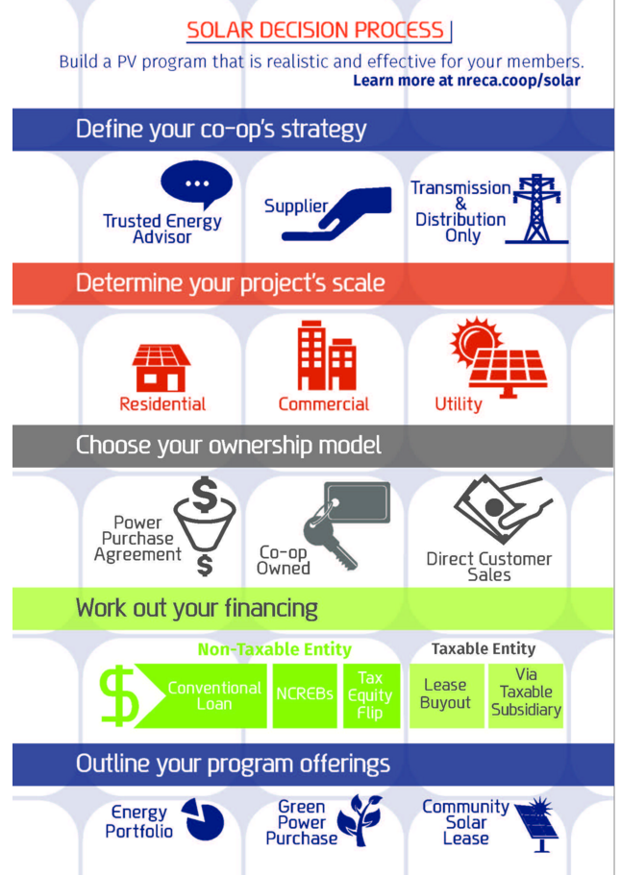
While the final policy document may be specific to a community solar program, the Board should consider all alternatives.

Guidelines for Developing a Board Policy for a Community Solar Program
The Board policy for a CSP establishes the purpose, objectives, responsibilities, and guidelines for how the program will be financed, supported, and operated. With an emphasis on transparency and recognition of the interests of the cooperative’s member-consumers, the CSP board policy should be stated in broad terms related to the essential requirements of the CSP, including the terms and benefits of member-consumer participation. Finally, the Board policy should reference the cooperative’s obligations to comply with any legal, safety, regulatory, and contractual mandates related to the participation and operations of the CSP program. The following outlines the possible elements of the CSP board policy:
NRECA’s courses and NCG’s consulting engagements follow a fairly standard template with which many cooperatives are familiar:
I. OBJECTIVE or PURPOSE (what is the policy about)
II. POLICY (a brief summary, usually not more than a paragraph, which summarizes the policy positions or decisions being made)
III. EXPECTATIONS (what is it that the policy is trying to accomplish; what actions are to be taken by the Board; what is staff being directed to do?)
IV. RESPONSIBILITIES (who is responsible for seeing that the policy is carried out and/or major tasks are being performed?; this is often where a synopsis of Board vs. CEO roles is articulated)

- Describe the overall purpose and objectives for the program. The purpose should reflect the rationale, intent, and value proposition to the member-consumership. The objectives refer to the initial goals and/or benefits expected to be achieved from the program. These stated objectives provide the context for evaluating the success of the program over time.
- Describe the CSP program. In general terms, describe what the program is, how member-consumers participate, how it will work, and on what size scale. This may include referencing the subscription model to be applied, the size of the CSP offering, and the general expected ranges or limits of CSP energy production.
- Outline the role of the cooperative, G&T, or any other third-party involvement. This outline may include a statement of beneficial use, ownership, and responsibility of care of the community solar facility. Note that the cooperative’s role is to oversee and evaluate the program’s performance. Explain the relationship involvement with any third-party entity for financing, purchased power, or shared ownership. In addition, reference the cooperative’s role (or that of a contracted third party) to maintain the infrastructure to ensure safe operations and expected energy production levels.
- Describe the broad terms for member-consumer participation. This description includes outlining the application process, subscription rates, financing of up-front costs, energy or bill credits, eligibility requirements, account transfers, and/or discontinuation terms. Consider referencing the approved details of the related consumer terms and conditions for the program as part of a companion document, similar to an approved tariff offering.
- Outline a statement of obligation to comply with industry standards and contract terms. This statement should reflect the cooperative’s intention to ensure that the solar facility meets standards related to safety, system interconnection, facility metering, and any regulatory requirements. Further, the statement should reference any contractual obligations.
- Outline definition of terms. To ensure the clarity of the related CSP Board policy, include or reference brief definitions of key terms used within the policy or to describe the program.

Do’s and Don’ts When Developing a Board Policy
Do | Don’t
- State the policy in broad yet comprehensive terms to direct the Board’s intent, guidelines, and parameters for how the program is financed, supported, and operated.  - Be clear about the cooperative’s role and obligations related to the CSP offering.  - Be clear about the CSP’s purpose, rationale, and expected member-consumership benefits.  - Develop a flexible policy recognizing the possibility of future changes or program updates.  - Develop the policy keeping in mind the mutual interests of the cooperative and consumers. | - Overlook or be vague on the critical roles and responsibilities for the cooperative, including the Board and management’s role, and any outside party involvement.  - Be too narrow and restrictive, or too general, as both can limit understanding and transparency for future considerations.  - Pursue the development of a policy without a clear business case, program details, and planned roll out.  - Have a policy that is unclear regarding the oversight role, objectives, or success factors for the CSP.

Sample Community Solar Board Policy
(ABC Cooperative – Power Program)

The following is provided as a sample policy. If used, it should be modified based on an electric cooperative’s legal and regulatory, financial, operational, policy, political, and other considerations.

- Statement of Purpose
In alignment with our environmental stewardship commitment, and with the intention to fulfill member-consumers’ interest in renewable energy source options, ABC Cooperative (Cooperative) is establishing a Community Solar Power Program (CSPP), a consumer-based community solar program offering. The program enables the Cooperative to offer an affordable option for member-consumers to offset their energy usage from a local solar power source while expanding the Cooperative’s knowledge base for distributed renewable technologies.

- Program Objectives
  - As part of our member-consumer loyalty strategy, expand the cooperative’s opportunities for consumers to participate in a local solar generation facility without subsidization by consumers who choose not to participate in the program.
  - Provide an economically viable option to meet member-consumer demand for generation from renewable sources.
  - Increase the cooperative’s knowledge level on the growing trend toward distributed renewable technologies and the related distribution service factors.
  - Enhance our community standing regarding environmental stewardship.

- Program Description
The program offering is derived from the approved CSPP business case and project plan. As outlined in the approved Solar Service Agreement with XYZ G&T Cooperative, a 0.5-MW solar generating facility located on Cooperative-owned land to produce solar power for use within the Cooperative distribution grid is authorized. The solar facility comprises 4,200 solar panel panels, each expected to produce approximately 470 kWh of power per year. Member-consumers who choose to participate in the program purchase a subscription unit equivalent to the investment of one solar panel. Participating member-consumers’ monthly bills are credited based on the average amount of energy production for each subscription unit. Those choosing not to participate will not see any change in their power bills resulting from this program.

- Policy Content and Provisions
  - As outlined in the Solar Service Agreement, XYZ G&T Cooperative finances, owns, and maintains the solar generating facility for the CSPP, and takes ownership of the resultant RECs in accordance with legal and regulatory requirements.
  - The Cooperative owns the site land for the CSPP’s solar generating facility.
  - Member-consumers purchase the production output of a solar panel as a subscription unit equivalent to the investment cost of a single solar panel. The total revenues received from the subscription units sold are projected to recover the total investments costs of the CSPP solar generating facility. The consumer subscription unit price for one solar panel is calculated based on the total investment and operating cost for similar-sized solar generating facilities over a 20-year lifespan. Any available investment tax credits applied are used to offset the initial investment in the project and reflected in the resultant up-front member-consumer subscription unit price.
  - Each month the Cooperative meters the total energy produced by the entire CSPP solar generating facility. Each participating member-consumer's bill will be reduced by the average number of kWhs for each equivalent subscription unit(s) purchased, priced at the current energy component of a member-consumer account's retail rate.
  - Eligible Cooperative member-consumers include residential and commercial accounts with monthly demand levels of less than 1,000 kV. Eligible Cooperative member-consumers complete an application to the Cooperative with the intent to purchase from 1 up to a maximum of 200 subscription units. Formal enrollment in the CSPP is initiated with a signed member-consumer agreement outlining the CSPP terms and payment received for the stated up-front subscription unit(s) total price. Non-deposited member-consumer accounts are eligible to pay the subscription unit price under an optional 24-month payment plan.
  - Member-consumers agree to participate in the program over the 20-year life of the solar generating facility. The CSPP is transferable if a member-consumer moves to different premises within the Cooperative’s service territory. If a CSPP participating member-consumer chooses to discontinue the program, the Cooperative will repurchase the subscription unit on a determined declining percentage basis per year.
  - CSPP terms, price details, and operating procedures will be documented and maintained by the Cooperative Member-consumer Service Department.
  - The CSPP program objective achievements, measures of effectiveness, and overall results will be formally reviewed annually with the Board. Any material changes to the CSPP shall be recommended and proposed by staff to the Board for their approval.
  - The installation and operations of the CSPP solar generating facility shall meet all local, state, federal, and industry requirements, including, but not limited to, the Standard for Interconnecting Distributed Resources with Electric Power Systems, National Electrical Safety Code, and all related compliance regulations.

- Responsibility
  - The Chief Executive Officer is responsible for the execution of this policy.

Notes on Policy Content and Provisions
It is important to be aware of the balance between providing so much detail that it limits the flexibility of the program design and the need for clear descriptions of the various roles and responsibilities. Below is a good starting point for the key roles and responsibilities that should be reflected in this section of the CSP policy:

- Who owns each aspect of the program/PV system?
  - Generation asset(s)
  - Land
  - Energy output
  - RECs
- Who operates and maintains the system?
- Who is responsible for decommissioning?
- How is it being financed, and what are the financial obligations/responsibilities?
- What are the terms for member-consumer eligibility and participation?
  - What is the subscription model?
  - How are bill credits applied?
  - What are the costs/rates of this program?
  - What are the eligibility terms and conditions?
- Who has responsibility for maintaining the policy documents?
- Are non-participating consumers subsidizing participating consumers?
- What are the Board oversight plans?
As much as possible, the policy document should refer directly to service agreements, business plans, and contracts developed by staff and third-party contractors.

Resources for Executive Management and Board of Directors

Tools and Resources from NRECA
National Consulting Group Policy Development Services for Community-Based Solar Projects
As interest in solar energy grows and the cost of deploying photovoltaic arrays becomes less prohibitive, many electric cooperatives are evaluating the feasibility of establishing CSPs. To assist with that process, NRECA is offering a suite of consulting services designed to help its co-op members deploy and operate solar generation projects.
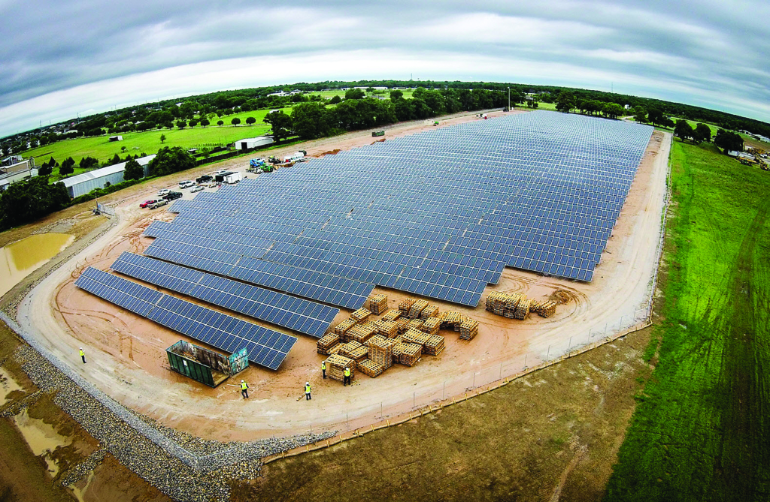
Through its National Consulting Group (NCG), and in collaboration with the association’s Business and Technology Strategies (BTS), NRECA is providing a resource to help mitigate cooperatives’ risks and costs – and increase the value of successful CSPs. NRECA’s consultants work alongside cooperatives’ personnel to evaluate and plan for the strategic, business, financial, and resource requirements of solar projects.

Our strategic consultants bring third-party value to the planning and development process, including assessment and creation of the strategic rationale for community solar. This process ensures that member co-ops and their consumers clearly understand the advantages and business drivers of proposed projects. Every co-op is unique, so we strive to provide a range of options that provide the best solution to each.

The overall principle for performing these services is one of guided facilitation:
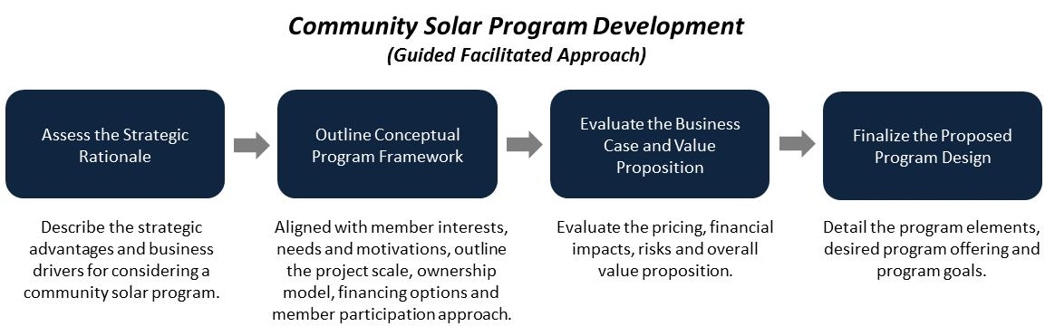
Contact: Henry.Cano@nreca.coop, 602-621-3905.

Solar Utility Network Deployment Acceleration (SUNDA)
NRECA created certain tools and resources pursuant to a DOE-funded project, the Solar Utility Network Deployment Acceleration (SUNDA). The purpose of the project was to enhance the ability of co-ops to design, deploy, and operate utility-scale, utility-owned solar PV systems at their facilities. Co-op project utilities installed more than 20 MW of utility-scale, utility-owned solar. SUNDA publications include the following:
- Cooperative Utility PV Field Manual ‒ NRECA’s Cooperative Utility PV Field Manual is a three-volume series designed to support electric cooperatives as they explore utility-scale solar PV:
  - Volume I: Business Models and Financing Options
  - Volume II: Planning, Design, Installation/Interconnection, and Commissioning
  - Volume III: Operations, Maintenance, and Monitoring
- SUNDA Reference Designs – Templates to design for 250-kW (single inverter and string inverter design), 500-kW, and 1-MW utility-scale PV solar projects
- Project Managers Quick Start Guide – Summary and checklist of Project Manager tasks and documentation requirements
- Cost and Financing Screening Tool for Utility-Scale Solar Projects – Open and editable spreadsheet for project financial examination
- Solar Communications Planning Guide – Guide to creating a communications plan for a solar project launch and marketing for increased participation
Available at: www.nreca.coop/SUNDA
This work, authored by the National Rural Electric Cooperative Association, was funded in whole or in part by the Department of Energy under U.S. Government contract DE-EE-0006333.

Cooperative Solar Case Studies
The following eight case studies illustrate innovative ways cooperatives are satisfying member-consumers’ demand for solar-derived electricity:
- Tri-County Electric Cooperative
- Southern Maryland Electric Cooperative
- San Miguel Power Association
- Okanogan County Electric Cooperative
- Green Power Electric Membership Cooperative
- Cherryland Electric Cooperative
- Kit Carson Electric Cooperative
- Great River Energy

Also available at: http://www.nreca.coop/solar-case-studies/

Comprehensive Web-Based Courses
NRECA offers this series of online webinars to help cooperatives address and evaluate community solar options. Topics include the following:
- Strategic Business Options
- Financing Options and Cost Estimates
- Technical Project Management
- Communications Best Practices
- Case Studies from Electric Co-ops
Available at: http://www.nreca.coop/what-we-do/bts/solar-utility-network-deployment-acceleration-project/comprehensive-course/

Distributed Generation (DG) Toolkit
NRECA created this DG toolkit to help electric co-ops address the legal, economic and technical issues raised by consumer-owned generation. These materials provide models and guidance that each co-op can adapt to its unique needs after consultation with management, legal counsel and system engineers. We suggest beginning with the “Business and Contract Guide for Interconnection” that will guide you through the process and provide you descriptions for each of the documents. With this toolkit, each co-op should be able to independently draft the rules, policies, tariffs, contract documents and retail rates required to respond to member requests for interconnection.
Available at: http://www.nreca.coop/nreca-on-the-issues/energy-operations/distributed-generation/

Additional Online Training Courses

State of Renewable Impact Analysis Software
This live 75-minute web conference presented by NRECA's Cooperative Research Network (CRN) provides co-ops with the basic technical guidance they will need to stay informed and on the leading edge of DG.
Available at: https://www.cooperative.com/conferences-education/web-conferences/pages/state-of-renewable-impact-analysis-software.aspx

MultiSpeak Integrator Training
Learn the advantages of implementing MultiSpeak® specification and how it works during this in-depth training session for co-op staff, consultants, and software integrators. The workshop covers Version 3.0, which has been implemented at utilities since 2005.
Available at: https://www.cooperative.com/conferences-education/courses/multispeak/Pages/default.aspx

Developing a Cyber Security and Risk Mitigation Plan
NRECA’s CRN made news when it made available to the public the Guide to Developing a Cyber Security and Risk Mitigation Plan. Written for electric cooperatives, the Guide can be used by any co-op to start immediately strengthening its security posture and charting a path of continuous improvement. This one-day, 8-hour workshop introduces the Guide and its related documents, and walks participants through the process of developing their own cyber security plans. The workshop covers risks posed by people, processes, and technology, and also looks at NERC CIP compliance. After taking this class, co-op staff will be ready to create their own cyber security plans.
Available at: https://www.cooperative.com/conferences-education/Lists/Courses/DispForm.aspx?ID=2&Title=(175.1)+Developing+a+Cyber+Security+and+Risk+Mitigation+Plan
This work, authored by the National Rural Electric Cooperative Association, was funded in whole or in part by the Department of Energy under U.S. Government contract DE-OE-OE0000222.

Enhancing IT Effectiveness: Managing and Planning the IT Function
This 2-day course covers the management techniques, current practices, tools, and resources crucial for effective IT planning, decision making, and leadership. The program also introduces a step-by-step approach to developing a strategic IT plan and guides participants in creating the foundation of an IT plan that can be taken back to their cooperatives.
Available at: https://www.cooperative.com/conferences-education/Lists/Courses/DispForm.aspx?ID=23&Title=(781.2)+Enhancing+IT+Effectiveness:+Managing+and+Planning+the+IT+Function

Solar Tools: Getting Co-ops Up to Speed on Their Solar Options
NRECA has pulled together tools and resources to answer questions and help you make informed decisions when exploring the installation of your own solar arrays or participating in cooperative solar development, like community solar. This webinar updates our online toolkit, which incorporates the experience and input from experts and consultants across the country.
Available at: https://www.cooperative.com/conferences-education/web-conferences/Pages/Solar-Tools-Getting-Co-ops-Up-to-Speed-on-Their-Solar-Options.aspx

