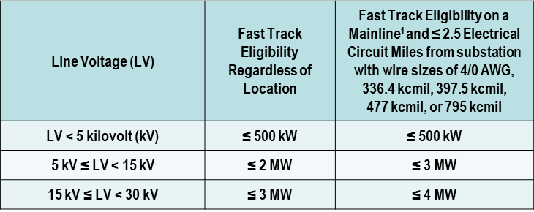

Inverter-based machine “Fast-Track” eligibility is based on thresholds in table below:
DER Fast-Track Study Process
For Extra Large Distributed Generations (includes BESS)
Study Process
Contact your
Transmission Provider
Member Study Screens
Small Generation Interconnection
Request ≤ 20 MW

Not Inverter-based
Synchronous and Induction machines
≤ 2 MW
Normal Study Process
No
No

Yes

No

Yes
No
Does DER pass all of the following study screens?
- No export of power beyond low-side revenue meter. This calculation is determined by measuring the aggregate of new and existing solar and/or battery storage capacity being less than 100% of the minimum load as measured by the revenue meter.
  - For solar PV standalone systems; use daytime minimum load (10am – 4pm for fixed panels and 8am – 6pm for tracking systems).
  - For solar/battery storage systems; use minimum load when batteries are discharging.
- Aggregate solar or battery source contributes less than 10% maximum fault current on substation low-side bus and does not cause distribution equipment to exceed 87.5% of short-circuit interrupting capability.
  - For solar PV or battery standalone systems; use 120% of inverter capacity to calculate fault current.
  - For solar/battery storage systems; use aggregate of both, 120% of inverter capacity for PV and 120% of inverter capacity for battery storage to calculate fault current.
- No substation construction is required to accommodate proposed generation.
- Revenue metering package is not required for billing or generation balancing.
No Transmission Communication needed.
For Load Forecasting provide PV/BESS capacity and inverter type (smart)/capacity

Yes

¹ For purposes of this table, a Mainline is the three-phase backbone of a circuit. It will typically constitute lines with wire sizes of 4/0 American wire gauge, 336.4 kcmil, 397.5 kcmil, 477 kcmil & 795 kcmil.

- Summary of Normal Study Process (two-way power-flow)
DER System Impact Study:
    - Short circuit analysis, stability analysis, power flow analysis, voltage drop study, flicker analysis, protection coordination studies, grounding review.
    - Distribution load flow study, analysis of equipment interrupting ratings, and impact on system operations.
Facilities Study:
  - Specifies and estimates the cost of the equipment, engineering, procurement, construction, and estimated construction time necessary to implement the conclusions of the system impact studies.
  - Identifies the electrical switching configuration of the equipment, the nature and estimated cost of the cooperative interconnection facilities and upgrades necessary, and estimates the time required to complete the construction and installation of such facilities.
- Study Cost
Generators will not be charged for general system assessment screens. These studies are typically for cumulative generation not meeting the Fast-Track eligibility and not exporting power out onto the ITS. Requirements are limited to fault current studies, ground grid analysis, and a reverse power protection study.
- Generators will be charged for two-way power flow studies requiring zone-distance relaying (Normal DER Study Process w/System Impact Study).
- Generators will be responsible for the cost of system upgrades identified in the study assessments.
- One-way or Two-way Power Flow? Protection Evaluation
Cumulative inverter-based machine which meets Fast-Track eligibility but fails a Member Screen and two-way power flow is not desired, then a reverse power relay may be needed:
- If the aggregate generation capacity is <100% of the minimum load for all line sections, meets the previous substation ground grid evaluation screen and the voltage/power quality screen below, then there are no further requirements.
  - Voltage/Power Quality screen is done in aggregate with existing generation on line section: (1) voltage regulation is maintained in compliance with relevant requirements; (2) voltage fluctuation is within acceptable IEEE 1453-2015; and (3) the harmonic levels of IEEE 519-2014.
- If >100% then a Reverse Power Relay (RPR) is added for fault detecting protection to trip distributed generation for transmission line faults. The reverse power relay is sensitive enough to operate on the excitation current (transformer core loss) taken by the transformer when the transmission source is removed.
Cumulative inverter-based machine which does not meet Fast-Track eligibility and/or Member Screens and two-way power flow is desired, then the Normal DER Study Process may be required and zone-distance relaying is needed:
- Zone-distance relaying – waits for the utility source breaker to open and trips generation with islanding protection at the point of interconnection. Includes distribution breaker and associated switches, 3 high-side CCVTs, and SEL 311c protective relay with the possibility of transfer trip carrier relaying at each transmission station and a transfer trip receiver panel at the distribution station for anti-islanding protection.
- Substation Ground Grid Evaluation? Safety Evaluation
Transmission Cooperative will perform a short circuit study review for the following:
- If fault current increase is <10%, there are no further study requirements.
- If fault current increase is >10%, a substation ground grid analysis is required.
- If the ground grid test passes, then there are no further study requirements.
- If the ground grid test fails, then a ground grid upgrade is required (will require a project).
Study Process if Previous DER Fast-Track Process Fails
Generation Interconnection Solar PV or Battery Storage - Small Generator Data Form for Study Screens

